Change Request
for the update of ISO 20022 financial repository items
Note: the purpose of this document is to give guidelines to parties who want to introduce a request to change an existing ISO 20022 message(s), or update other items of the ISO 20022 financial repository. Such change requests are subject to the approval of the ISO 20022 Standards Evaluation Group(s) in charge of the related message/item or to the approval of the Technical Support Group (TSG), if the requested change relates to the Business Application Header (BAH). Please consult the iso20022.org website for additional details on the maintenance process. Change requests are to be sent to iso20022ra@iso20022.org. All change requests conforming to this template received by June 1st will be considered for development in the following yearly ISO 20022 maintenance cycle which completes with publication of new message versions in April/May of the following year.
- Origin of the request:
A.1 Submitter:
SIX Interbank Clearing Ltd
A.2 Contact person:
Roman Locher
roman.locher@six-group.com
T +41 58 399 4125
A.3 Sponsors:
SIX Interbank Clearing is involved in several committees focused on questions of standardization concerning the national and international payment traffic. In this role SIX Interbank Clearing acts as a representative of the Swiss financial industry. SIX Interbank Clearing also operates the Swiss RTGS systems SIC for Swiss Francs (monitored and steered by the Swiss National Bank) and euroSIC in Euro.
This Change Request is supported by the national committee “Taskforce ISO V2019 Interbank”, representing Swiss National Bank, UBS, Credit Suisse, PostFinance, Raiffeisen, Zürcher Kantonalbank, Entris Banking.
- Related messages:
- pacs.004 (latest version: pacs.004.001.11)
- pacs.008 (latest version: pacs.008.001.10)
Note:
The change request explained below is primarily required for the Swiss Interbank community in the messages pacs.004/008. However, since the affected element is also used in other pacs messages, it should be checked whether a general adjustment of all messages of the category "Payments Clearing and Settlement" is necessary.

- Description of the change request:
In this change request, the Swiss Interbank community requests an extension of the element "Charges Information" (<ChrgsInf>, Type Charges7):
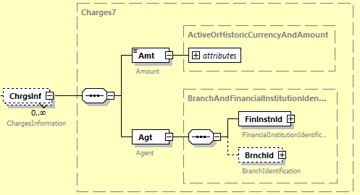
Currently, the <ChrgsInf> element only supports information about the charges amount and to which agent the charges are to be paid.
Within the Swiss Interbank Market Practice, for certain bilaterally agreed charges, further information on the specific nature of the charges must be added to this information. Since there is currently no suitable element for this purpose, a text sub-element within <Agt> element (that is not actually intended for this purpose) has to be used for these cases.
To fix this workaround, the Swiss community requests to add an additional optional sub-element "Type" within the <ChrgsInf> element. The Swiss community proposes to design the new element in same form as already known from "Cash Management" messages as ChargeType3Choice:
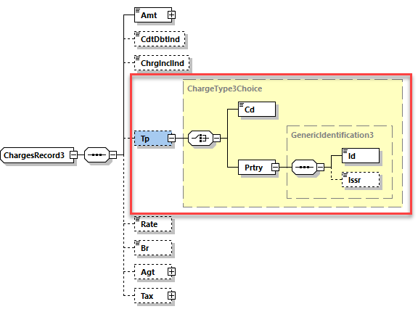
- Purpose of the change:
As mentioned before, this extension is intended to fix a currently used workaround within Swiss Interbank Market Practice so that the <Agt> sub-element can be used in the exclusive sense of this element.
With a proper delivery of this additional information, the Swiss community believes that more transparency about the reasons for a charges deduction can be created, especially if these charges are part of a bilateral agreement. Furthermore, with this additional information in the payload of the interbank payment message, subsequent clarifications based on end-customer queries can be avoided.
- Urgency of the request:
The change should be implemented in the regular yearly maintenance cycle with publication per next ISO 20022 version in spring 2023.
- Business examples:
Extract from Swiss Interbank Market practice, document “Implementation Guidelines for ISO 20022 Interbank Messages, Customer Payments (pacs.008)”:
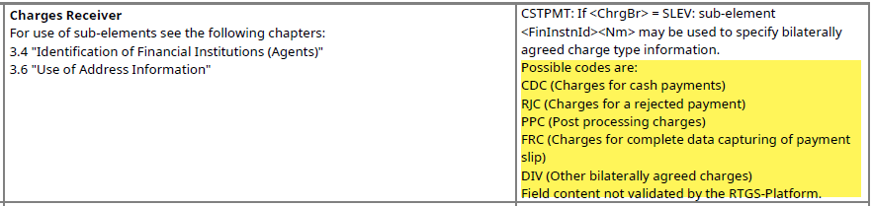

- SEG/TSG recommendation:
This section is not to be taken care of by the submitter of the change request. It will be completed in due time by the SEG(s) in charge of the related ISO 20022 messages or the TSG for changes related to the BAH.

Consider |  |  | Timing
- Next yearly cycle: 2022/2023
(the change will be considered for implementation in the yearly maintenance cycle which starts in 2022 and completes with the publication of new message versions in the spring of 2023)
- At the occasion of the next maintenance of the messages
(the change will be considered for implementation, but does not justify maintenance of the messages in its own right – will be pending until more critical change requests are received for the messages)
- Urgent unscheduled
(the change justifies an urgent implementation outside of the normal yearly cycle)
 |  |  | - Other timing:
Comments:

Reject
Reason for rejection:

