**Change Request**

**for the update of ISO 20022 financial repository items**

1. **Origin of the request:**

Clearstream

Hendrik Melchior [hendrik.melchior@clearstream.com](mailto:hendrik.melchior@clearstream.com), +49 69 211-13263

Catarina Marques [catarina.marques@cleastream.com](mailto:catarina.marques@cleastream.com) +352 243 36411

1. **Related messages:**

Seev.001, seev.002, seev.003, seev.004, seev.005, seev.008

1. **Description of the change request:**

General Meeting messages can't report a negative FaceAmt in balance type, e.g. ELIG (eligible position). For Units the negative reporting it is allowed.

1. **Purpose of the change:**

*The following change reflects the identification of a gap/inconsistency, which is deemed unvoluntary, but gives way to potential incorrect results in terms of reporting of negative positions (ELIG – eligible balance) when expressed in FAMT.*

*The inconsistency was reported to and registered by the SMPG under the reference SMPG_CA517_Instructed Quantity in Meeting Instructions. This information is provided to facilitate the life-cycle tracking of the issue at hand.*

*Process summary*

Intermediaries that notify Lenders and Borrowers about any upcoming corporate event incl. general meetings by MT564 on lent Securities.

For voting rights and consent fee events, lenders that want to exercise their voting rights should recall their Securities within the stipulated deadlines.

The Lender, however, can only participate in the vote up to the amount that they hold on their account on record date: the Borrower must return Securities in time to enable participation.

Therefore, the Intermediary must generate the notification, so the borrower is aware that the return of the securities is required by the (earliest) event deadline.

Each securities lending/borrowing movement *thus leads* to a negative eligible position for the borrower – as the positive position is on BORR - will generate the issue.

*Proposed changes:*

*Two options may apply – see business examples – with the least disruptive to be considered for the issue resolution.*

1. **Urgency of the request:**

*SR2023*

1. **Business examples:**

Option 1 (simple change):

Change Face Amount type by removing “minInclusive: 0” and bring it in line with the reporting for Units where this restriction doesn’t exist.

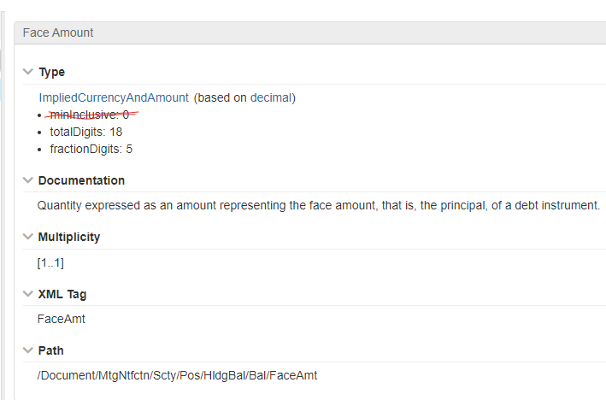

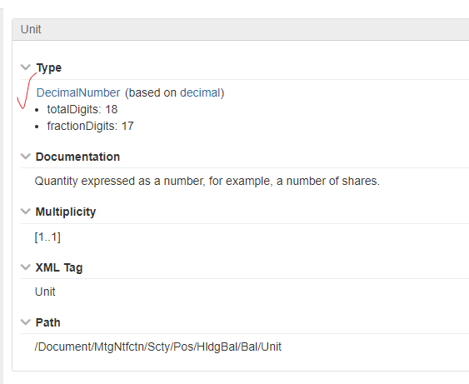

Option 2 (complex change):

The balance structure of General Meeting messages deviate from Corporate Actions messages where a “SignedQuantity” element in the balances with a ShortLongPosition element exist. This allows to specify a negative quantity whether in unit or face amount or in amortised value and allow full coexistence with ISO 15022.

The issue is therefore strictly limited to “HoldingBalances” in GM messages only.

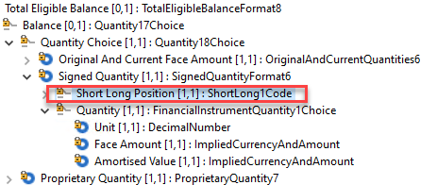

1. **SEG/TSG recommendation:**

*This section is not to be taken care of by the submitter of the change request. It will be completed in due time by the SEG(s) in charge of the related ISO 20022 messages or the TSG for changes related to the BAH.*

|  |  |  |  |
| --- | --- | --- | --- |
| **Consider** | |  | **Timing** |
|  | | - **Next yearly cycle: 2022/2023**  (the change will be considered for implementation in the yearly maintenance cycle which starts in 2022 and completes with the publication of new message versions in the spring of 2023) | |  |
|  | | - **At the occasion of the next maintenance of the messages**  (the change will be considered for implementation, but does not justify maintenance of the messages in its own right – will be pending until more critical change requests are received for the messages) | |  |
|  | | - **Urgent unscheduled**  (the change justifies an urgent implementation outside of the normal yearly cycle) | |  |  |
|  | | - **Other timing:** | | |  |

Comments:

|  |  |
| --- | --- |
| **Reject** |  |

Reason for rejection: