Change Request
for the update of ISO 20022 financial repository items
Note: the purpose of this document is to give guidelines to parties who want to introduce a request to change an existing ISO 20022 message(s), or update other items of the ISO 20022 financial repository. Such change requests are subject to the approval of the ISO 20022 Standards Evaluation Group(s) in charge of the related message/item or to the approval of the Technical Support Group (TSG), if the requested change relates to the Business Application Header (BAH). Please consult the iso20022.org website for additional details on the maintenance process. Change requests are to be sent to iso20022ra@iso20022.org. All change requests conforming to this template received by June 1st will be considered for development in the following yearly ISO 20022 maintenance cycle which completes with publication of new message versions in April/May of the following year.

- Origin of the request:
A.1 Submitter: ACI Worldwide
A.2 Contact person: Kevin Jiang (Kevin.jiang@aciworldwide.com) / Yasuyuki Endoh (yasuyuki.endoh@aciworldwide.com)
A.3 Sponsors: ACI Worldwide / Japan CardNet

- Related messages:

- caaa.004.001.10 AcceptorCompletionAdviceResponseV10
- caaa.005.001.11 AcceptorCancellationRequestV11
- caaa.006.001.10 AcceptorCancellationResponseV10
- caaa.007.001.11 AcceptorCancellationAdviceV11
- caaa.008.001.10 AcceptorCancellationAdviceResponseV10

- Description of the change request:

Our client current business messages have some special fields includes multiple tags with a TLV structure (such as field 48 and 62 in ISO 8583 standard) and need to map to the nexo/CAPE messages. We would like to use the AdditionalInformation <AddtlInf> field under Tx.TxDtls to save these values because this field also uses the Id/Value structures and can be easily mapped to ISO 20022 ATICA message field Body.Tx.AddtlData. We understand all the ATICA request and response messages include Body.Tx.AddtlData field but nexo/CAPE only have the following message types support Tx.TxDtls.AddtlInf field.
AcceptorAuthorisationRequest
AcceptorAuthorisationResponse
AcceptorCompletionAdvice
The following message types don’t have this field:
AcceptorCompletionAdviceResponse
AcceptorCancellationRequest
AcceptorCancellationResoonse
AcceptorCancellationAdvice
AcceptorCancellationAdviceResoonse
So, we would like to raise this CR to add the AdditionalInformation <AddtlInf> field to above message types too.

- Purpose of the change:

The purpose of this Change Request is to add additional information fields to all message types and to keep consistent with ISO 20022 ATICA messages.
The CR includes two requirements: one is the field need to use TLV format and can support multiple tags; the other is it need to presence in both request and response messages as some of the business also need to pass back the information in response. We can also accept if the community suggest to use any other field which can support above requirements.
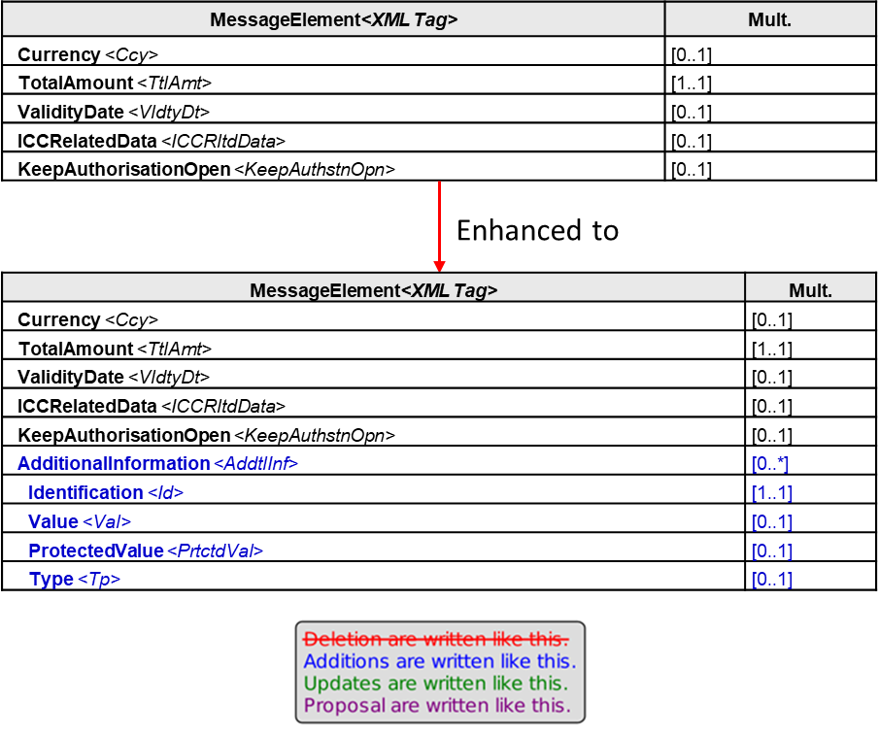

- Urgency of the request:

Normal

- Business examples:

For example, in case the terminal needs to pass the local public transport transaction information to the Acquirer and Issuer. It will set the J50 tag with the information and send it through to the back end host.

- SEG/TSG recommendation:
This section is not to be taken care of by the submitter of the change request. It will be completed in due time by the SEG(s) in charge of the related ISO 20022 messages or the TSG for changes related to the BAH.

Consider |  |  | Timing
- Next yearly cycle: 2022/2023
(the change will be considered for implementation in the yearly maintenance cycle which starts in 2022 and completes with the publication of new message versions in the spring of 2023)
- At the occasion of the next maintenance of the messages
(the change will be considered for implementation, but does not justify maintenance of the messages in its own right – will be pending until more critical change requests are received for the messages)
- Urgent unscheduled
(the change justifies an urgent implementation outside of the normal yearly cycle)
 |  |  | - Other timing:
Comments:

Reject
Reason for rejection:

