Change Request
for the creation of letter type External Codes for CTCCR Message Set

Origin of the request:

A.1 Submitter:
Name of the company, organization, group, initiative or community that submits the change request. | Russian Corporate Market Practice Group (RU-CMPG) under aegis of Russian National Member and User Group (ROSSWIFT)

A.2 Contact person:
Person that can be contacted for additional information on the request
A.2.1.1. First name, Last name | Timothy Romaslovsky
A.2.1.2. Email address | Timothy.Romaslovsky@swift-russia.ru
A.2.1.3. Telephone | +7 499 272 0232, +7 910 458 8897
A.2.2.1. First name, Last name | Dmitry Shein
A.2.2.2. Email address | Dmitry.Shein@swift-russia.ru
A.2.2.3. Telephone | +7 499 272 0232, +7 967 266 9340
A.2.3.1. First name, Last name | Maxim Zemtsov
A.2.3.2. Email address | Maxim.Zemtsov@swift-russia.ru
A.2.3.3. Telephone | +7 499 272 0232

A.3 Sponsors:
If the submitter acts on behalf of or has gained support from other organisations, groups, initiatives or communities, these should be listed as sponsors.
The market practice which embraces the proposed changes is supported by major banks (e.g. Gazprombank, UniCredit Bank, Deutsche Bank, ING Bank, Moscow Credit Bank, ROSBANK, etc.) and implemented by these banks to interact with their customers (corporates).

Description of the change request:
Specify the request type: creation of new code set, update of existing code set, deletion of existing code set.
For the creation of a new code set or for updating an existing code set, also complete the table in section H below. For the addition of new codes, all the details must be specified, including a proposed code, a proposed code name, a clear definition, and any other indications, such as an example or format to be published with the code set.

Request type: creation, update, deletion | Creation

Related External Code Set:
For updating or deleting an existing code set, indicate the exact name of the code set as indicated in the External Code Sets documents on iso20022.org. For creating a new code set, indicate a proposed name for the new code set.
A specific change request form must be completed for each code set to be updated.

ExternalLetterType1Code

Purpose of the change:
Background, business context, community of users interested by the change and expected benefits/savings.
This section must explain why the existing code set needs to be changed. The reason for the update may be a business reason (e.g., evolution of market practice, or creation of new financial instruments), a technical reason (e.g., automation of the business process, or switch from a batch to a real time process), a regulatory reason (introduction, generally mandatory, of new rule/law) or the extension of the user community (newly identified business requirements).

To get standard in line with real practice and to provide initial values for CR # 9 of MCR 197 of Fast Track CTCCR Message Set Maintenance 2021.

Urgency of the request:
By default, valid change requests, subsequently approved by the SEG will be included in the following quarterly publication of External Code Sets, unless decided otherwise by the SEG.
If there is a need to have the new version of the related code set published earlier, the reason for the urgency and the expected consequences of a delay should be described here. Acceptance of such an unscheduled publication is subject to approval by the SEG.

Will be synchronized with MCR 197 of Fast Track CTCCR Message Set Maintenance 2021

Business examples:
Provide examples illustrating usage of the code set and indicate messages where the code set may be used.
In local practice is used long list of local codes for for auth.026.001.02 - CurrencyControlRequestOrLetterV02 letter types differentiation during processing, particularly, related with the local law. As it seems to Russian community, those are not needed to expand onto worldwide usage. So, to be in line with ISO 20022 principles in the MCR 197 of Fast Track CTCCR Message Set Maintenance 2021 (Change Number #9) we ask to register a standard “xor” structure to combine separately as External Code Sets as proprietary codes:
QUOTE
In the CurrencyControlRequestOrLetterV02 into the structure of component RequestOrLetter for Type element the data type SupportDocumentType1Code (Definition: Specifies a type of supporting document) replacing by the new complex type SupportLetterType1Choice (Definition: Choice of format for the type of supporting letter).
The new complex type SupportLetterType1Choice contains the following XOR elements: Code, Proprietary as shown below:
B1. Code <Cd>
Presence: [1..1]
Definition: Type of supporting letter expressed as an ISO 20022 code.
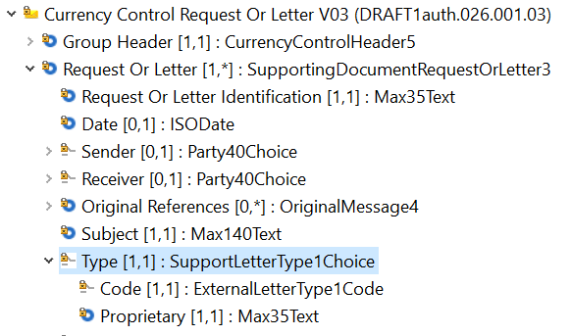

Code <Cd> contains the letter type as published in an external letter type code list (see " ExternalLetterType1Code" data type above for details).
XOR
B2. Proprietary <Prtry>
Presence: [1..1]
Definition: Type of supporting letter expressed as a proprietary code.
Proprietary <Prtry> contains a character string with a maximum length of 35 characters (see "Max35Text" for details).
END QUOTE
As far as we understand to be registered an External Code element it will have already registered External Codes.
So, in the External Code Sets Table we add ExternalLetterType1Code with new three following codes:
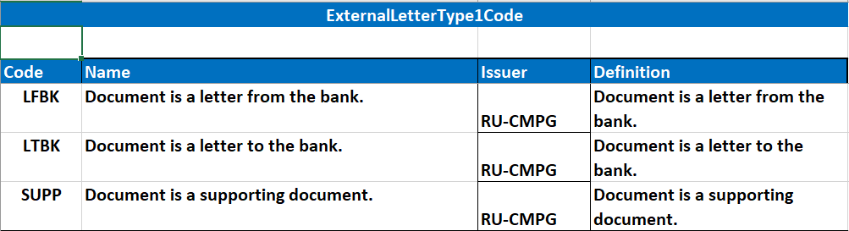
as the most comprehensive code words for auth.026.001.02 - CurrencyControlRequestOrLetterV02 processing.

SEG recommendation:
This section will be completed by the SEG in charge of the related External Code Set.

Accept |  |  | Timing
 |  |  | Next possible quarterly release
 |  |  | Urgent request

Comments:

Reject

Reason for rejection:

DESCRIPTION OF THE CHANGE REQUEST

Type | Code Value | Code Name | Code Definition | Replaced By | Additional Information
Addition  Update  Deletion | 4 char |  | Clear and concise definition. Repetition of the code name is not allowed. | Code value (if applicable) | Usage, use case(s) or any additional information useful for the usage of the code.

