Change Request
for the update of an External Code Set used in ISO 20022

- Origin of the request:
A.1 Submitter: Daniele Pasqualini, the Italian Banking Community, CBPR+
A.2 Contact person: Kiyono Hasaka, SWIFT
- Related External Code Set:
ExternalCategoryPurpose1Code and ExternalPurpose1Code
Description of the change request:
Create the following codes for Category Purpose and Purpose:

Code Name | Name | Definition
CMSW | Sweep the account | Transaction contains a cash management instruction, requesting to sweep the account of the ordering customer.
CMTO | Top the account | Transaction contains a cash management instruction, requesting to top the account of the ordering customer above a certain floor amount.
CMZB | Zero balance the account | Transaction contains a cash management instruction, requesting to zero balance the account of the ordering customer.

- Purpose of the change:
The purpose of this change is to support new category purpose and purpose codes.
CBPR+ Working Group reviewed corporate use cases of multi-bank liquidity sweeps and found the need to register additional category purpose and purpose codes to be compatible with legacy MT 101 in preparation for MT-MX co-existence starting in Nov 2022.
Currently, corporates indicate a cash management code, “CMSW” (sweep the account), “CMZB” (zero balance the account) or “CMTO” (top the account) in MT 101 field 23E instruction code. These codes are mainly intended for the receiver of the MT 101 performing liquidity sweeps on behalf of corporates. The receiver of MT 101 may map these instruction codes to the field 70 of the MT 103 and report similar codes also in the MT 940/2 field 61.
As interbank is adopting ISO 20022, the equivalent codes should be available in the Category Purpose and Purpose elements to support liquidity sweep operations and facilitate interoperability across MT and MX standards.
This use case of corporate liquidity sweeps have a clear multi-bank and cross-border nature, and have strong potential for benefitting from enhanced and structured data to attain consistent multi-bank sweep operations enabled by ISO 20022.
There is a commonly used code “INTC” Intra Company Payment in the MT 101, MT 103 and ISO, however, the definition is too broad to trigger liquidity sweep operations and apply the relevant pricing.
Therefore, this change request is to support additional codes for both Category Purpose and Purpose to consistently trigger corporate liquidity management operations globally.
Urgency of the request:
Next quarterly update of the external code list is fine.
- Business examples:
Please refer to two use cases of the interbank customer credit transfer initiation message sent by the Initiating Party to the Forwarding Agent or the Debtor Agent for corporate-initiated liquidity sweeps and FI-initiated liquidity sweeps below extract from the CBPR+ UHB:
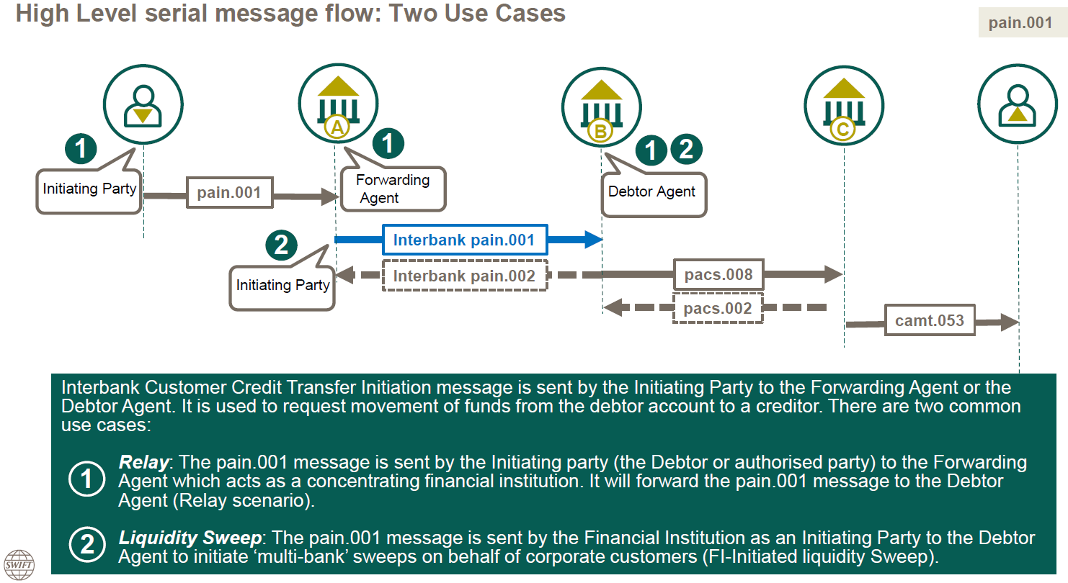

- SEG recommendation:
This section will be completed in due time by the SEG in charge of the related External Code Set.

Accept |  |  | Timing
 |  |  | - Next possible quarterly release
 |  |  | - Other timing:
Comments:

Reject
Reason for rejection:

