Change Request
for the update of ISO 20022 financial repository items

- Origin of the request:
A.1 Submitter: Payments Canada
A.2 Contact person: Malene McMahon, 613 415 4991, mmcmahon@payments.ca
A.3 Sponsors: n.a.

- Related messages:
pacs.008 and pacs.009 and any messages containing these rules.

- Description of the change request:
There are some rules in the base ISO 20022 pacs.008 and pacs.009 message related to the Previous Instructing Agent. Below is snippet (from the offline Editor) of these rules:
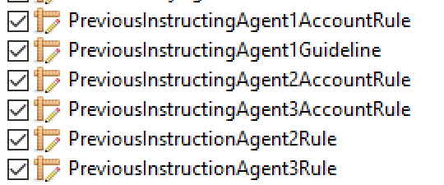
The name of the last 2 rules listed above uses the word “Instruction” instead of the correct word “Instructing” for the name of the rule. This should be corrected to reflect the appropriate name for the rule.
- Purpose of the change:
To correct a mistake in the naming of a base ISO 20022 message rule.

- Urgency of the request:
Not urgent, but should be corrected perhaps at the next maintenance cycle.

- Business examples:
Not sure business examples are necessary for this change request since it is a correction of an apparent mistake in the naming of two rules.
- SEG/TSG recommendation:
This section is not to be taken care of by the submitter of the change request. It will be completed in due time by the SEG(s) in charge of the related ISO 20022 messages or the TSG for changes related to the BAH.

Consider |  |  | Timing
- Next yearly cycle: 2022/2023
(the change will be considered for implementation in the yearly maintenance cycle which starts in 2022 and completes with the publication of new message versions in the spring of 2023)
- At the occasion of the next maintenance of the messages
(the change will be considered for implementation, but does not justify maintenance of the messages in its own right – will be pending until more critical change requests are received for the messages)
- Urgent unscheduled
(the change justifies an urgent implementation outside of the normal yearly cycle)
 |  |  | - Other timing:
Comments:

Reject
Reason for rejection:

