Change Request
for the update of ISO 20022 financial repository items

- Origin of the request:
A.1 Submitter:
DESSUG CA – PSG (Deutsche SWIFT Securities Market User Group - Corporate Actions - Proxy Subgroup Germany).
This group represents more than 20 different institutions including domestic and global proxy providers and registrars with a key role in the German General Meeting process.

A.2 Contact person:
PSG Chair - Hendrik Melchior (employer change to Clearstream Banking Frankfurt in July)
PSG Deputy Chair - Daniel Schäfer, Daniel.Schaefer@hsbc.de, Phone +49 211 910-2362
Sabine Wolff, Sabine.Wolff@clearstream.com, Phone +352-243-3 66 40
SEG GM-ET Member (Germany) - Sven Gunkel, sven-a.gunkel@db.com, Phone +49 69910-60715
SEG GM-ET Member (Germany) - Rainer Prior, Rainer.Prior@linkmarketservices.de, Phone +49 6196 8870 514

A.3 Sponsors:
German Market - including domestic and global proxy providers with a key role in the German General Meeting process.
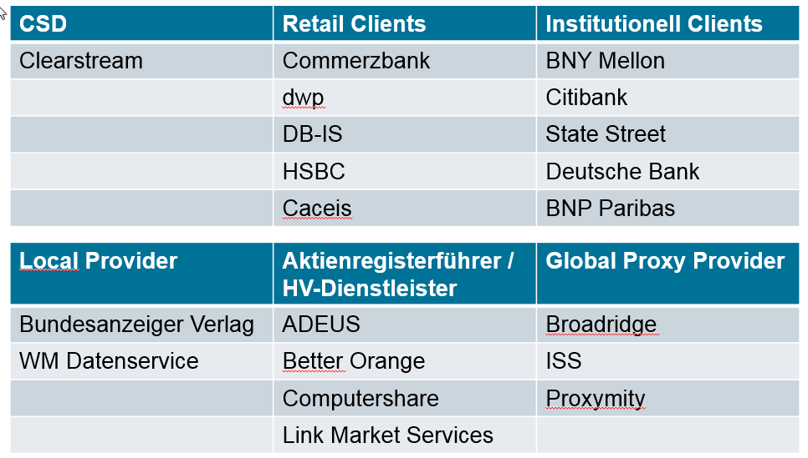

- Related messages:
seev.001.xxx.xxx

- Description of the change request:
This is Change Request #3 of 3 ParticipationMethod/Deadline+VoteDeadline

Please consider the description and definition change requested as #1 of 3 of Issuer Deadline for Voting under Participation to Issuer Deadline for the notification of Participation.
The Issuer Deadline for Voting under Participation method Electronic Vote does not allow to distinguish different deadlines applicable to voting via Email versus voting via STP-connected applications, i.e. electronic voting can be up to and during the meeting whereas votes per (e-)mail need to be processed manually and hence, afford a buffer before the meeting takes place.

Definition Change:
Votes received via Email need to be processed manually and hence, afford a buffer before the meeting takes place. Therefore, we request to capture voting via Email under voting via Mail (/Document/MtgNtfctn/Vote/VoteMthds/VoteByMail) and not under Electronic Vote (/Document/MtgNtfctn/Vote/VoteMthds/ElctrncVote).

Therefore the description for participation method EVOT should be changed to: Vote participation is through electronic means like dedicated standards messaging or web based voting applications.
(current definition: Vote participation is through electronic means like email or dedicated standards messaging or web based voting applications.)

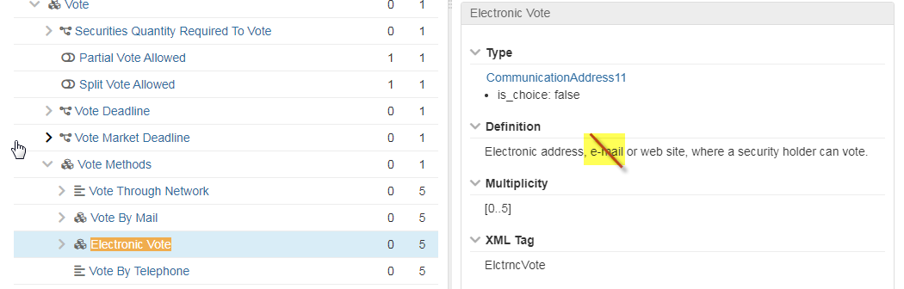

Field Structure Change:
In addition the email address should be moved from “Electronic vote” in the vote methods into “Vote by Mail” incl. definition change to remove the word e.mail in Vote Method – Electronic Vote as below.

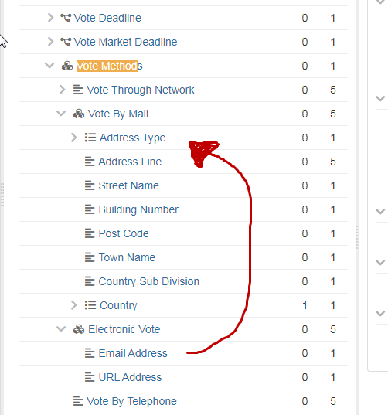

- Purpose of the change:
This section must explain why the existing ISO 20022 messages need to be changed. The reason for the update may be a business reason (e.g., evolution of market practice, or creation of new financial instruments), a technical reason (e.g., automation of the business process, or switch from a batch to a real time process), a regulatory reason (introduction, generally mandatory, of new rule/law) or the extension of the user community (newly identified business requirements).
The requested change is based on processing that differs for votes received via Email versus votes received via voting platform which does not need to be the same as the virtual attendance.
It is understood that an URL may refer to a voting platform for which the deadline shall be closer to the meeting than Email.

- Urgency of the request:
N/A

- Business examples:

AGM date: 28.04.2021
Applicable participation methods: MAIL/EVOT/VIRT
Deadline for the notification of the participation: 21.04.2021 21:59 UTC-Z
Vote Market Deadline:
Vote by Mail 26.04.2021 21:59 UTC-Z
Vote through Network 21.04.2021 21:59 UTC-Z
Electronic Voting 28.04.2021

- SEG/TSG recommendation:
This section is not to be taken care of by the submitter of the change request. It will be completed in due time by the SEG(s) in charge of the related ISO 20022 messages or the TSG for changes related to the BAH.

Consider |  |  | Timing
 |  |  | - Next yearly cycle: 2021/2022  (the change will be considered for implementation in the yearly maintenance cycle which starts in 2021 and completes with the publication of new message versions in the spring of 2022) |  | X
- At the occasion of the next maintenance of the messages
(the change will be considered for implementation, but does not justify maintenance of the messages in its own right – will be pending until more critical change requests are received for the messages)
- Urgent unscheduled
(the change justifies an urgent implementation outside of the normal yearly cycle)
 |  |  | - Other timing:
Comments:

Reject
Reason for rejection:

