Change Request
for the update of ISO 20022 financial repository items
- Origin of the request:
A.1 Submitter:
DESSUG CA – PSG (Deutsche SWIFT Securities Market User Group - Corporate Actions - Proxy Subgroup Germany)
This group represents more than 20 different institutions including domestic and global proxy providers and registrars with a key role in the German General Meeting process.

A.2 Contact person:
PSG Chair - Hendrik Melchior (employer change to Clearstream Banking Frankfurt in July)
PSG Deputy Chair - Daniel Schäfer, Daniel.Schaefer@hsbc.de, Phone +49 211 910-2362
Sabine Wolff, Sabine.Wolff@clearstream.com, Phone +352-243-3 66 40
SEG GM-ET Member (Germany) - Sven Gunkel, sven-a.gunkel@db.com, Phone +49 69910-60715
SEG GM-ET Member (Germany) - Rainer Prior, Rainer.Prior@linkmarketservices.de, Phone +49 6196 8870 514

A.3 Sponsors:
German Market - including domestic and global proxy providers with a key role in the German General Meeting process.
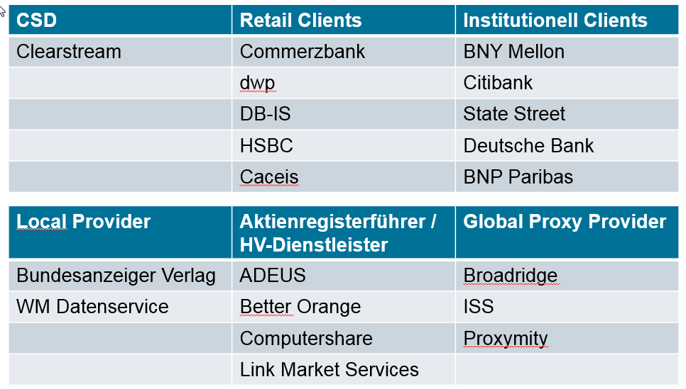
- Related messages:
Seev.001.xxx.xxx
Seev.004.xxx.xxx

- Description of the change request:
Add new Proxy Type; Neutral Proxy [NEPR]
Definition: Neutral proxy nominated by the issuer to execute votes on behalf of investors at the meeting.

- Purpose of the change:
In Germany it is common market practice that the issuer nominates one or more neutral Proxy persons (names are often not known to the shareholders) to execute votes on behalf of investors at the meeting.
To ensure the execution of the received votes, the Neutral Proxy person can sub-delegate the proxy role to another person in case of non-availability, e.g. sickness.

This “Neutral Proxy [NEPR]” is not the Chairman [CHRM] nor can be Discretionary [DISC], because the name of the Proxy is not known, but it is specified that the person has been nominated by the issuer to execute shareholder votes at the meeting.

- Urgency of the request:
N/A

- Business examples:
Seev.001.xxx.xxx
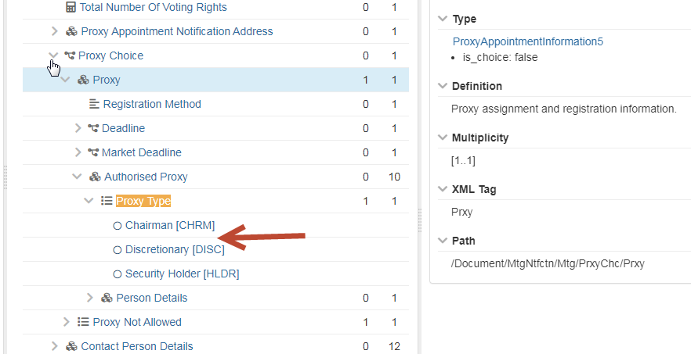

Proxy Type
1 1
- Chairman [CHRM]
- Neutral Proxy [NEPR]
- Discretionary [DISC]
- Security Holder [HLDR]

Seev.004.xxx.xxx
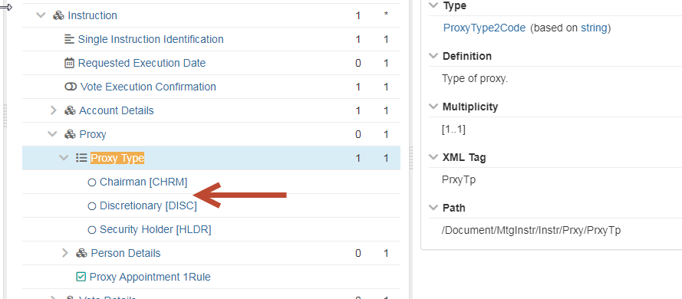

It is not required to add “Neutral Proxy [NEPR]” in the vote details (e.g. Vote Per Agenda Resolution, Vote For All Agenda Resolutions, Vote Instruction For Meeting Resolution) of the seev.004.xxx.xxx instructions message. The “Neutral Proxy [NEPR]” can’t amend received votes or can be instructed to decide on their own how the votes should be executed.

Proxy Type
1 1
- Chairman [CHRM]
- Neutral Proxy [NEPR]
- Discretionary [DISC]
- Security Holder [HLDR]

- SEG/TSG recommendation:
This section is not to be taken care of by the submitter of the change request. It will be completed in due time by the SEG(s) in charge of the related ISO 20022 messages or the TSG for changes related to the BAH.

Consider |  |  | Timing
 |  |  | - Next yearly cycle: 2021/2022  (the change will be considered for implementation in the yearly maintenance cycle which starts in 2021 and completes with the publication of new message versions in the spring of 2022) |  | X
- At the occasion of the next maintenance of the messages
(the change will be considered for implementation, but does not justify maintenance of the messages in its own right – will be pending until more critical change requests are received for the messages)
- Urgent unscheduled
(the change justifies an urgent implementation outside of the normal yearly cycle)
 |  |  | - Other timing:
Comments:

Reject
Reason for rejection:

