Change Request
for the update of ISO 20022 financial repository items
- Origin of the request:
A.1 Submitter:
DESSUG CA – PSG (Deutsche SWIFT Securities Market User Group - Corporate Actions - Proxy Subgroup Germany)
This group represents more than 20 different institutions including domestic and global proxy providers and registrars with a key role in the German General Meeting process.

A.2 Contact person:
PSG Chair - Hendrik Melchior (employer change to Clearstream Banking Frankfurt in July)
PSG Deputy Chair - Daniel Schäfer, Daniel.Schaefer@hsbc.de, Phone +49 211 910-2362
Sabine Wolff, Sabine.Wolff@clearstream.com, Phone +352-243-3 66 40
SEG GM-ET Member (Germany) - Sven Gunkel, sven-a.gunkel@db.com, Phone +49 69910-60715
SEG GM-ET Member (Germany) - Rainer Prior, Rainer.Prior@linkmarketservices.de, Phone +49 6196 8870 514

A.3 Sponsors:
German Market - including domestic and global proxy providers with a key role in the German General Meeting process.
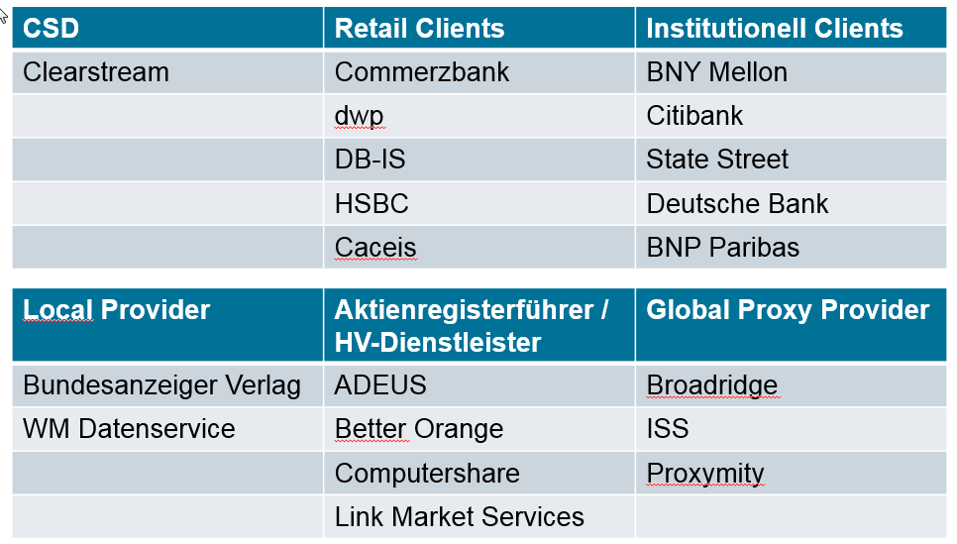

- Related messages:
seev.001.xxx.xx

- Description of the change request:
This is Change Request #2 of 3 ParticipationMethod/Deadline+VoteDeadline

Different vote deadlines can be set by the issuer. E.g. electronic voting can be received until the end of the meeting whereas votes per mail need to be processed manually before the meeting.
In the current setup only one deadline can be specified which applies for all voting methods. Therefore the two voting deadlines
- Vote deadline < VoteDdln>
- Vote market deadline < VoteMktDdln>
should be different for each vote method.

Field Structure Change :
Allow distinct vote deadlines and vote market deadlines for individual vote methods.
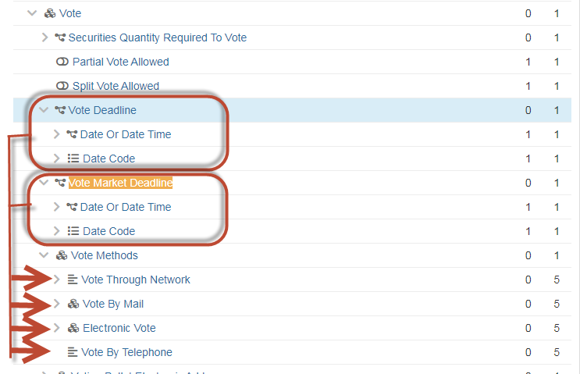

Note; this change request is similar to the MT564 Date/Time harmonization several years ago. Deadlines were removed from general details level (Seq. D) to option level (Seq. E).
- Purpose of the change:
To clearly differentiate between the Deadline for the notification of participation (table 3 D2) and Deadline for Voting (table 3 D3).
These deadlines should be used differently for participation methods and vote methods.

- Urgency of the request:
N/A

- Business examples:
AGM date: 28.04.2021
Applicable participation methods: MAIL/EVOT/VIRT
Deadline for the notification of the participation: 21.04.2021 21:59 UTC-Z
Vote Market Deadline:
Vote by Mail 26.04.2021 21:59 UTC-Z
Vote through Network 21.04.2021 21:59 UTC-Z
Electronic Voting 28.04.2021

- SEG/TSG recommendation:
This section is not to be taken care of by the submitter of the change request. It will be completed in due time by the SEG(s) in charge of the related ISO 20022 messages or the TSG for changes related to the BAH.

Consider |  |  | Timing
- Next yearly cycle: 2021/2022
(the change will be considered for implementation in the yearly maintenance cycle which starts in 2021 and completes with the publication of new message versions in the spring of 2022)
- At the occasion of the next maintenance of the messages
(the change will be considered for implementation, but does not justify maintenance of the messages in its own right – will be pending until more critical change requests are received for the messages)
- Urgent unscheduled
(the change justifies an urgent implementation outside of the normal yearly cycle)
 |  |  | - Other timing:
Comments:

Reject
Reason for rejection:

