Change Request
for the update of an External Code Set used in ISO 20022
- Origin of the request:
A.1 Submitter: Deutsche Bundesbank on behalf of the Eurosystem / 4CB
A.2 Contact person:
Steffen Faehrmann (steffen.faehrmann@bundesbank.de) +496923884010
Mustafa Sahin (mustafa.sahin@bundesbank.de) +496923884005
A.3 Sponsors: none
- Related External Code Set:
ExternalInvestigationExecutionConfirmation1Code
- Description of the change request:
Add following codes to the set:

Code | Code Name | Definition
FTNA | Cancellation Request Forwarded To The Next Agent | The cancellation request has been forwarded to the next agent for execution.  This code should only be utilised where a Case Id is not present.
- Purpose of the change:
The code will be used in the following element on camt.029 (RsltnOfInvstgtn/Sts/Conf):
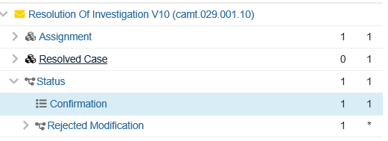
During the market consultation for the design of message usage guidelines for Eurosystem’s RTGS (group meeting held on May 29th, 2018) it was identified that a Status code did not exist in the Resolution of Investigation to respond to a Request for Cancellation advising that the request had been forwarded to the Next Agent in the payment transaction. During this meeting it was agreed to request a new status code, FTNA, to RsltnOfInvstgtn/Sts/Conf, reflecting this use case. It was agreed to have the new code registered in the ISO20022 ExternalInvestigationExecutionConfirmation1Code external code set.
For explanation: RTGS provides two functionalities to RTGS participants sending camt.056 cancellation requests:
1) to revoke a pending payment order and
2) to forward the request to the next agent in the payment chain, if the payment has already been settled and has reached the final status, or if the payment has not been processed via RTGS, but via the alternative MI (such as EBA E1/S1).
In the second case, RTGS forwards the camt.056 cancellation request to the next agent in the payment chain. After forwarding the cancellation request, RTGS informs the sender of the camt.056 about this action with a camt.029 RsltnOfInvstgtn/Sts/Conf code FTNA (Forwarded to The Next Agent), i.e. no further actions are taken by RTGS. For this second functionality, the MI is considered as an interlinking provider, rather than a payment actor to enable the community to reach those counterparties using the alternative network service provider to ESMIG.
Further background information:
The process will be initiated by an RTGS account holder via sending of a camt.056 message to RTGS. RTGS will process and validate the message. If the original payment instruction has a positive final status (settled), or the original payment instruction cannot be found in the list of payments of the current business day, the cancellation request is considered as a recall and is forwarded to the next Agnet. A notification is sent by RTGS to the Assigner of the cancellation request informing them that the request has been forwarded to the Next Agent. At this point the code FTNA will be used, on the x-path RsltnOfInvstgtn/Sts/Conf, as a status of confirmation.
The place on the flow where the code is going to be used is marked in green. The following image is the business process model for the payment instruction revocation or recall.
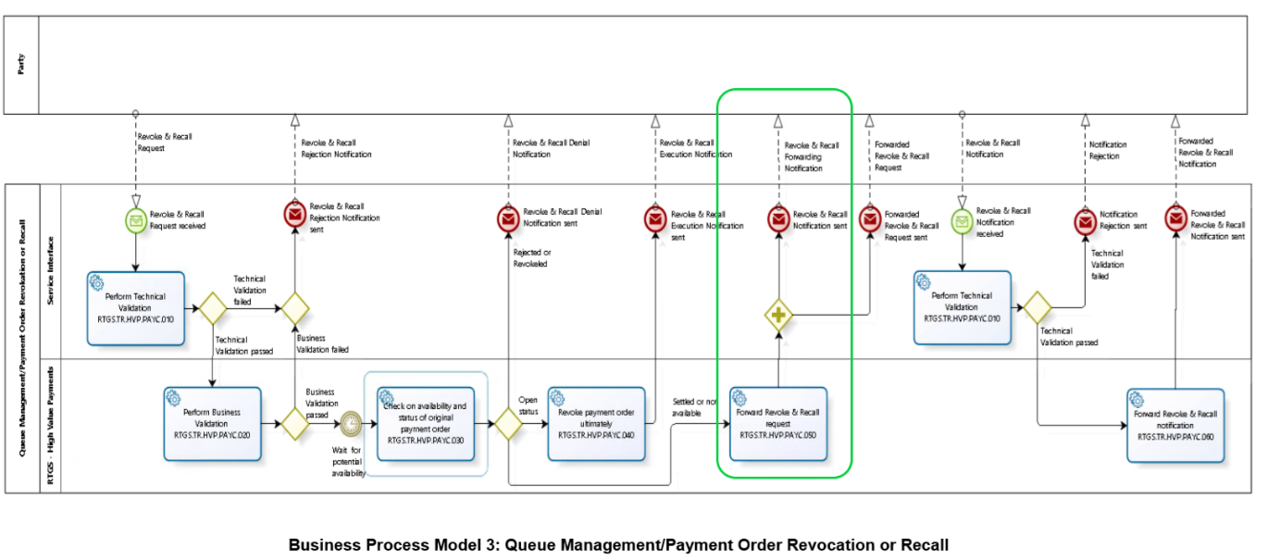
In the flows below, the exact point where the code is going to be used can be seen:
1) Status of payment instruction is settled, the cancellation request is processed by participant B

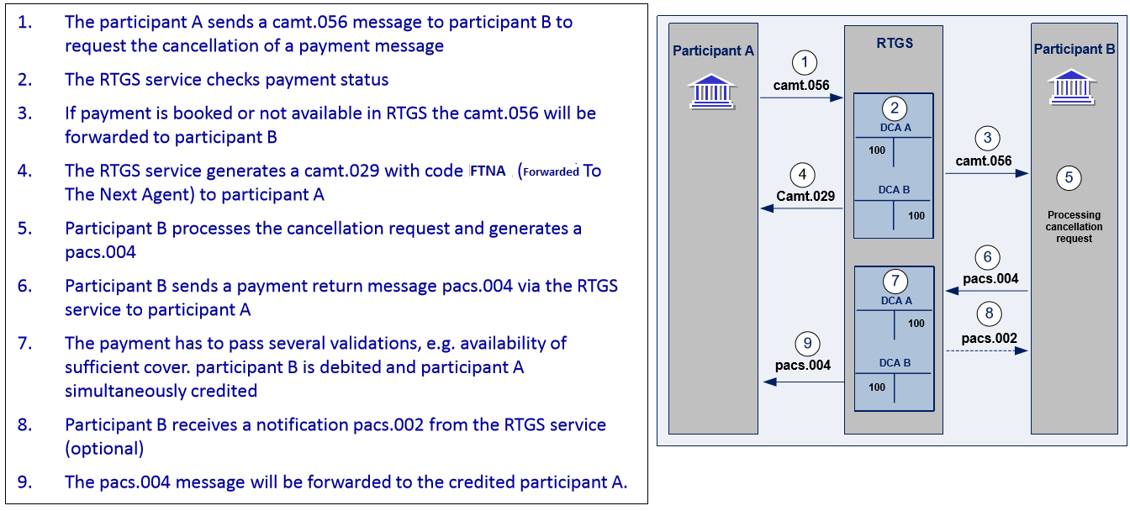
2) Status of payment order final, the revocation request cannot be process by participant B
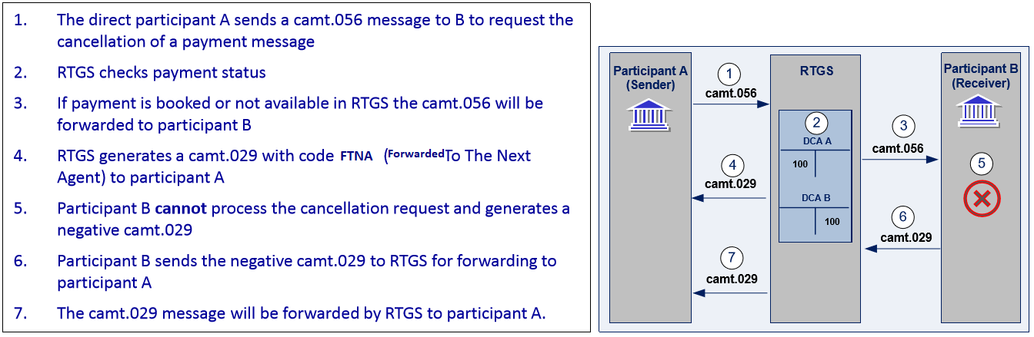
To inform the requester that the cancellation request has been forwarded to participant B, RTGS sends camt.029 with the code FTNA.
Urgency of the request:
Eurosystem is working on ISO 20022 implementation, and the camt.029 is part of the payments portfolio of messages to be implemented. Therefore, it is requested to implement this change with the next release in 2020.
- Business examples:
The following example is the camt.029 shown on the flows, on the point D.
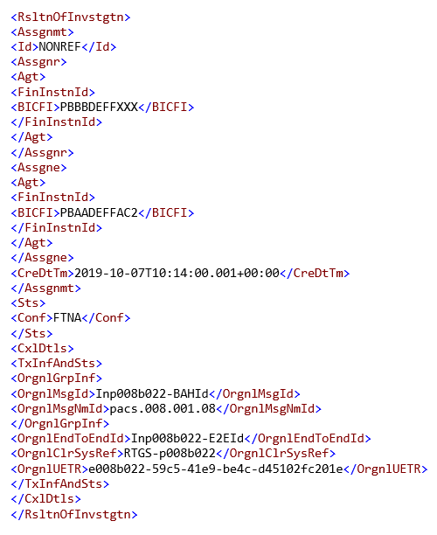
- SEG recommendation:
This section will be completed in due time by the SEG in charge of the related External Code Set.

Accept |  |  | Timing
 |  |  | - Next possible quarterly release
 |  |  | - Other timing:
Comments:

Reject
Reason for rejection:

