Change Request
for the update of ISO 20022 financial repository items
- Origin of the request:
A.1 Submitter:
European Payments Council (EPC)
Cours Saint-Michel 30A, B-1040 Brussels
Belgium

A.2 Contact person:
Mr Valentin Vlad (valentin.vlad@epc-cep.eu)

A.3 Sponsors:
EPC Multi-stakeholder Group on E-invoice Presentment and Payments (EIPP MSG) upon invitation by the ERPB
Organisations represented in the EIPP MSG:
- EPC (European Payments Council)
- EESPA (European E-invoicing Service Providers Association)
- EACT (European Association of Corporate Treasurers)
- EuroCommerce (association representing the retail, wholesale and international trade sector in Europe)
- EcommerceEurope (association representing companies selling goods and/or services online to consumers in Europe)

- Related messages:
pain.013.001.06 and pain.014.001.06

- Description of the change request:
Changes to respond to real business needs in the market, and new usage of the pain.013 and pain.014

Changes applicable both to pain.013 and pain.014:

Change 1: Addition of Expiry Date

Element Name | Element Definition | Multiplicity | DataType
Expiry Date | Date by which the Debtor must have accepted/rejected the creditor payment activation request. Beyond this date, the request becomes void and therefore cannot be accepted/rejected anymore. | [0..1] | DateAndDateTimeChoice

Requested Location of the Expiry Date in the pain.013 and pain.014 :

Element Name | pain.013 | pain.014
Expiry Date | Level 2/below Requested Execution Date | Level3/in Original Transaction Reference below Requested Execution Date

Change 2: Addition of Amount Modification Allowed Indicator

Element Name | Element Definition | Multiplicity | DataType
Amount Modification Allowed Indicator | Indicates if the Debtor is allowed to pay a different amount than the amount requested by the Creditor. | [0..1] | Boolean (TRUE/FALSE)

Requested Location of the ‘Amount Modification Allowed Indicator’ in the pain.013 and pain.014 :

Element Name | pain.013 | pain.014
Amount Modification Allowed Indicator | Level 2, under Payment Information, after 'Payment Method' and  Level 3, under credit transfer transaction, after the element 'amount'  Rule to be created that if it is used at Payment Information level, it cannot be used at Credit Transfer Transaction Level and vice versa. If used at Level 2, the Amount Modification Allowed Indicator applies to each individual transaction included in the Credit Transfer Transaction section. | Level 4, under Original Transaction Reference, after 'amount'

Change 3: Addition of Early Payment Allowed Indicator
Element Name | Element Definition | Multiplicity | DataType
Early Payment Allowed Indicator | Indicates if the Debtor is allowed to make the payment before the Requested Execution Date specified by the Creditor. | [0..1] | Boolean (TRUE/FALSE)
Requested Location of the ‘Early Payment Allowed Indicator’ in the pain.013 and pain.014 :

Element Name | pain.013 | pain.014
Early Payment Allowed Indicator | Level 2, under Payment Information, after 'Requested Execution Date' and  Level 3, under Credit Transfer Transaction after ‘Amount’  Rule to be created that if it is used at Payment Information level, it cannot be used at Credit Transfer Transaction Level and vice versa. If used at Level 2, the Early Payment Allowed Indicator applies to each individual transaction included in the Credit Transfer Transaction section. | Level 4, under Original Transaction Reference, after 'Requested Execution Date'

Change 4: Addition of 'Delay Penalty’

Element Name | Element Definition | Multiplicity | DataType
Delay Penalty | Information regarding the delay penalty applied by the Creditor if the Debtor pays after the execution date requested by the Creditor. | [0..1] | Max140Text

Requested Location of the ‘Delay Penalty’ in the pain.013 and pain.014 :

Element Name | pain.013 | pain.014
Delay Penalty | Level 2, under Payment Information, after 'Requested Execution Date' and  Level 3, under Credit Transfer Transaction after ‘Amount’  Rule to be created that if it is used at Payment Information level, it cannot be used at Credit Transfer Transaction Level and vice versa. If used at Level 2, the Delay Penalty applies to each individual transaction included in the Credit Transfer Transaction section. | Level 4, under Original Transaction Reference, after 'Requested Execution Date'

Change 5: Addition of 'Immediate Payment Rebate’

Element Name | Element Definition | Multiplicity | DataType
Immediate Payment Rebate | Discount rate applied by the Creditor for immediate payments on reception of the pain.013. | [0..1] | PercentageRate

Requested Location of the ‘Immediate Payment Rebate’ in the pain.013 and pain.014 :

Element Name | pain.013 | pain.014
Immediate Payment Rebate | Level 2, under Payment Information, after 'Requested Execution Date' and  Level 3, under Credit Transfer Transaction after ‘Amount’  Rule to be created that if it is used at Payment Information level, it cannot be used at Credit Transfer Transaction Level and vice versa. If used at Level 2, the Immediate Payment Rebate rate applies to each individual transaction included in the Credit Transfer Transaction section. | Level 4, under Original Transaction Reference, after 'Requested Execution Date'

Change 6: Addition of 'Guaranteed Payment Requested Indicator’

Element Name | Element Definition | Multiplicity | DataType
Guaranteed Payment Requested Indicator | Indicates if a payment guarantee is requested by the Creditor, assuming that a payment guarantee contract exists between the different actors. | [0..1] | Boolean (TRUE/FALSE)

Requested Location of the ‘Guaranteed Payment Requested Indicator’ in the pain.013 and pain.014 :

Element Name | pain.013 | pain.014
Guaranteed Payment Requested Indicator | Level 2, under Payment Information, after 'Requested Execution Date' and  Level 3, under Credit Transfer Transaction after ‘Amount’  Rule to be created that if it is used at Payment Information level, it cannot be used at Credit Transfer Transaction Level and vice versa. If used at Level 2, the Guaranteed Payment Requested Indicator applies to each individual transaction included in the Credit Transfer Transaction section. | Level 4, under Original Transaction Reference, after 'Requested Execution Date'

Changes applicable only applicable to pain.014:

Change 7: Addition of ‘Accepted Amount’

Element Name | Element Definition | Multiplicity | DataType
Accepted Amount | Amount accepted to be paid by the Debtor. Usage Rule: can be used only if the element ‘Amount Modification Allowed Indicator’ received in the pain.013 is TRUE. | [0..1] | ActiveCurrencyAndAmount

Requested Location of the ‘Paid Amount’ in the pain.014 :

Element Name | pain.013 | pain.014
Accepted Amount | N/A | Level 3, under Transaction Information and Status, after Status Reason Information

Change 8: Addition of ‘Debtor Decision DateTime’

Element Name | Element Definition | Multiplicity | DataType
Debtor Decision DateTime | DateTime of the Debtor's acceptation or rejection of the request.  Usage Rule: If present it must be less than the value of ‘Expiry Date’ in the pain.013 message. | [0..1] | ISODateTime

Requested Location of the ‘Debtor Decision DateTime in the pain.014 :

Element Name | pain.013 | pain.014
Debtor Decision DateTime | N/A | Level 3, under Transaction Information and Status, after Acceptance Date Time

Change 9: Addition of ‘Guaranteed Payment Indicator’

Element Name | Element Definition | Multiplicity | DataType
Guaranteed Payment Indicator | Indicates if the Debtor Agent guarantees the payment, assuming that an agreement regarding the guarantee of payment exists between the different actors. | [0..1] | boolean (TRUE/FALSE)

Requested Location of the ‘Guaranteed Payment Indicator’ in the pain.014 :

Element Name | pain.013 | pain.014
Guaranteed Payment Indicator | N/A | Level 3, under Transaction Information and Status, after Status Reason Information

Change 10: Addition of ‘Early Payment Indicator’
Element Name | Element Definition | Multiplicity | DataType
Early Payment Indicator | Indicates if the Debtor will make the payment before the Requested Execution Date specified by the Creditor.  Usage Rule: If present, it cannot be TRUE if the value of ‘Allowed Early Payment Indicator’ received in the pain.013 message is FALSE. | [0..1] | Boolean (TRUE/FALSE)
Requested Location of the ‘Early Payment Indicator’ in the pain.014 :

Element Name | pain.013 | pain.014
Early Payment Indicator | N/A | Level 3, under Transaction Information and Status, after Status Reason Information

For the pain.013:

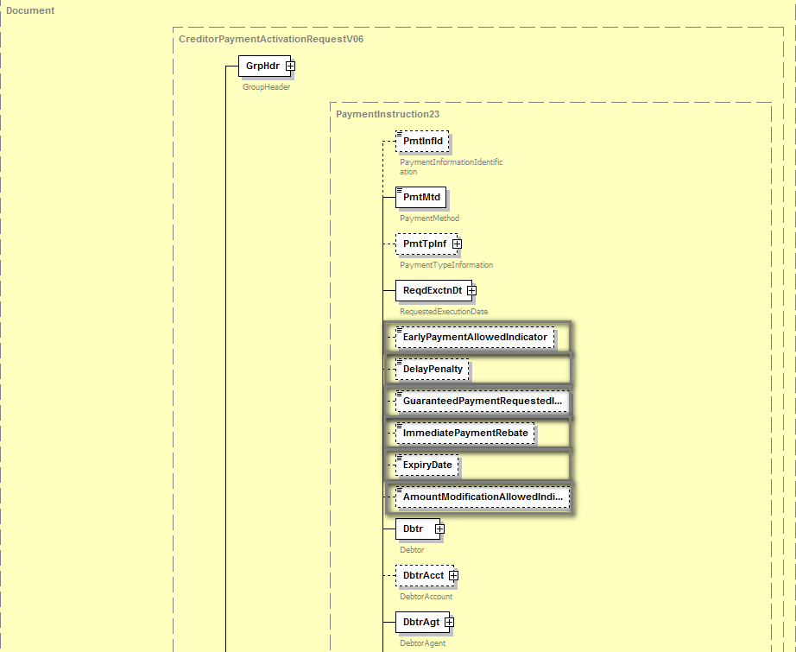
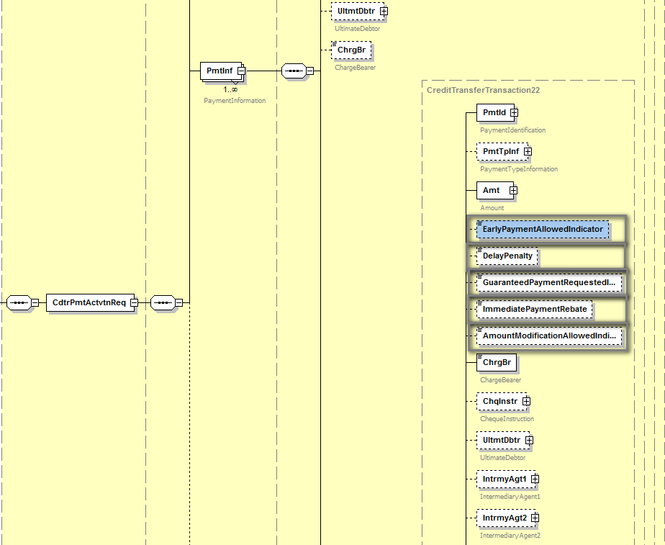
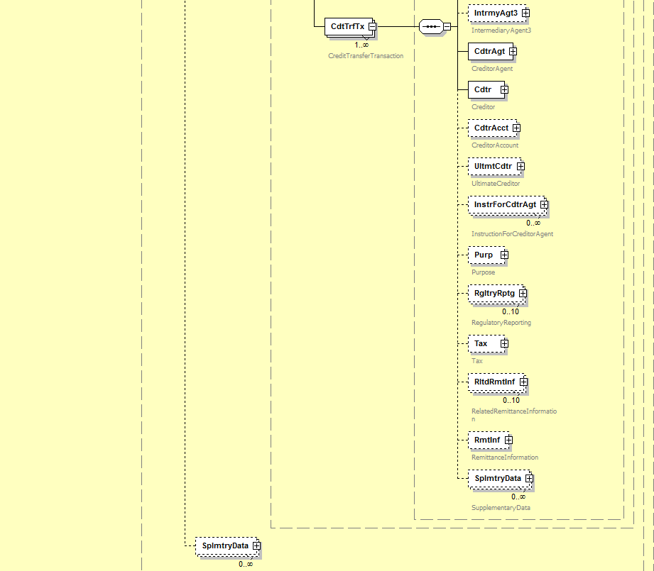
For the pain.014:

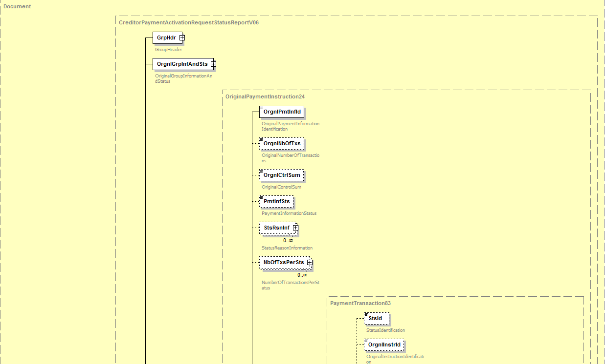
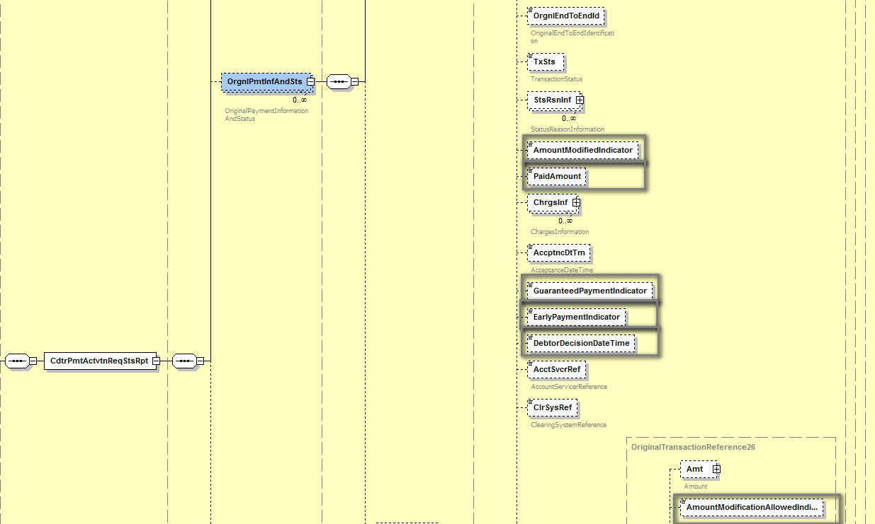
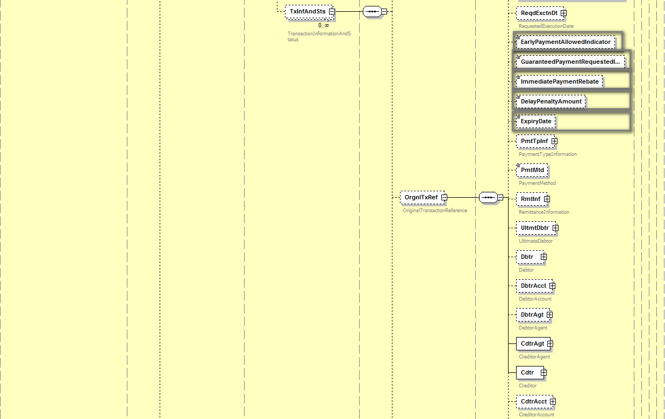

- Purpose of the change:
At the end of the year 2016 the ERPB mandated a working group to define the minimum requirements for EIPP at the levels of business rules and technical standards and report on the outcome of its work in one year. The working group’s report was approved and published in November 2017. The ERPB took note of the report and endorsed the set of minimum requirements for the development of pan-European interoperability of EIPP services. Following a step-by-step approach, the work would first focus on the adoption of a technical ISO 20022-based message for Request-to-pay for EIPP and the harmonisation of other EIPP “servicing messages”. The ERPB invited the EPC to coordinate the required work among the payment services providers with the involvement of other stakeholders including e-invoicing solution providers.
Responding to the invitation of the ERPB to coordinate the follow-up work, the EPC created the EPC Multi-stakeholder Group on EIPP (EIPP MSG) which started its activity in February 2018. As indicated by the ERPB, the EIPP MSG is focusing in 2018 on the adoption of a standardised technical ISO 20022-based message for Request-to-pay and the harmonisation of other identified servicing messages related to EIPP.
After analysing the existing pain.013 and pain.014 messages (Creditor Payment Activation Request and Report), the EIPP MSG considered that they are to a large extent suitable for the requirements related to Request-to-pay identified in the ERPB report.
It has been estimated however that some elements are required to add more flexibility regarding the expectations of the Seller/Payee in terms of payment parameters and the decisions of the Debtor/Payer. For example, the Payee may wish to inform the Payer that the amount of the Request-to-pay can be different from the amount really paid, and the Payer may wish to inform the Payee in the response message that the amount will be different and the real value that will be paid. Two fields allowing minimal information about penalties for late payments or discounts for early payments were also considered useful to respond to requirements related to financing techniques such as factoring.
A new data element was added to fulfil a need from some markets in relation to the payment expected time. More precisely the Payee can inform the Payer if the payment is allowed before the requested execution time. A corresponding element has been added in the pain.014 message.
By making use of these new fields, the new pain.013 and pain.014 messages would answer to the needs of:
- Invoice issuers (Payees/Sellers) by offering them more flexibility in informing the Payers/Debtors about commercial terms of the transaction.
- Invoice receivers (Payers/Debtors) by proposing them more possibilities to inform the Payees/Sellers on specific decisions in relation with the commercial terms or upcoming payment transaction.
- All actors by offering elements for further uses of the Request-to-pay beyond the E-invoicing, such as E-commerce and retail commerce in physical shops.
- Urgency of the request:
- Business examples:

In B2C (individual customers) or B2b (small enterprises), the Seller adds payment conditions to the Request-to-pay. The message is sent through the network (PSPs, EISPs, Clearing Houses, etc) and reaches the Payer’s domain. After checking the conditions and making selections, the Payer gives its consent and instructs its PSP on the response to be sent via the pain.014 message and on the upcoming payment message (pacs.008).

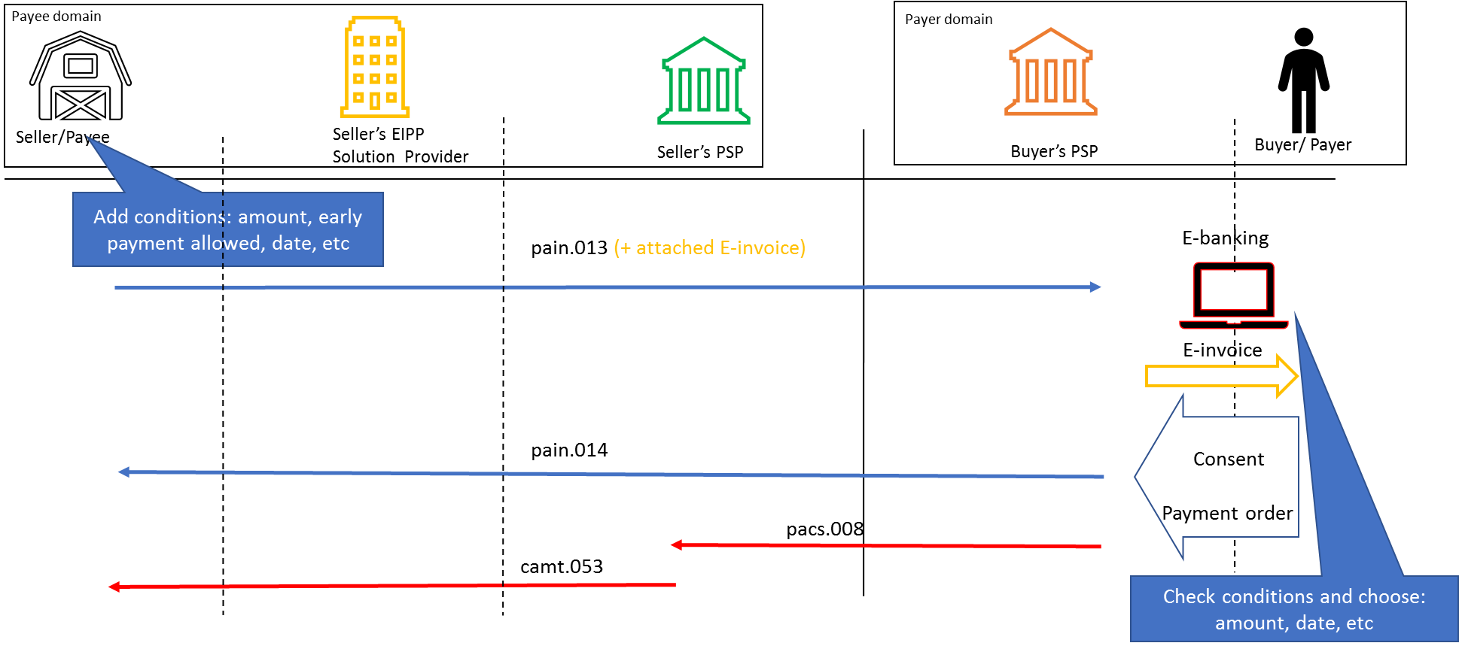

- SEG/TSG recommendation:

Consider |  | X | Timing
 |  |  | - Next yearly cycle: 2018/2019  (the change will be considered for implementation in the yearly maintenance cycle which starts in 2018 and completes with the publication of new message versions in the spring of 2019) |  | X
- At the occasion of the next maintenance of the messages
(the change will be considered for implementation, but does not justify maintenance of the messages in its own right – will be pending until more critical change requests are received for the messages)
- Urgent unscheduled
(the change justifies an urgent implementation outside of the normal yearly cycle)
 |  |  | - Other timing:
Comments: Decision made at the Payments SEG meeting on July 9th, 2018.

Reject
Reason for rejection:

ECB’s Euro Retail Payments Board, see the ERPB statement published in November 2017: (link ERPB Statement, page 3)
Report of the ERPB Working Group on EIPP - November 2017

