Change Request
for the update of an External Code Set used in ISO 20022
- Origin of the request:
A.1 Submitter: The Clearing House
A.2 Contact person:
Michael Thomas
212-612-9205
Michael.thomas@theclearinghouse.org
A.3 Sponsors:
None
- Related External Code Set:
3 – Cash Clearing System
- Description of the change request:
The Clearing House is seeking the addition of a new external clearing system code of ‘TCH’ for the Element Clearing System Code representing The Clearing House, LLC’s Real-Time Payments system (RTP) as a clearing system.
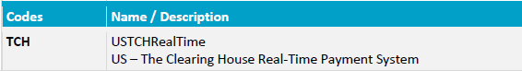
The format of ClearingSystem and ExternalCashClearingSystem1Code under Payments Clearing and Settlement – Maintenance 2016
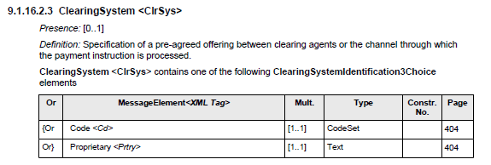
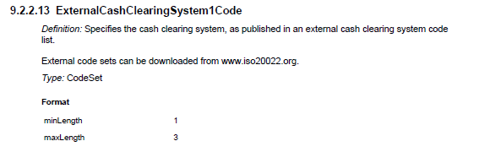
- Purpose of the change:
The Clearing House is creating a new ISO 20022 based Real-Time Payments system in the US, and needs an ISO 20022 compliant unique identifier to indicate payments that pass through this new infrastructure.
- Urgency of the request:
The RTP system will be live in Q1 2017, with testing taking place in 2H 2016. Approval of this request is sought for Q3 2016.
- Business examples:
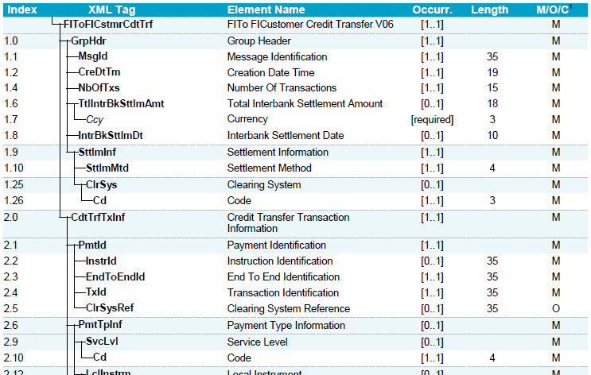
New code = TCH
- SEG recommendation:

Accept |  | X | Timing
 |  |  | - Next possible quarterly release |  | X
 |  |  | - Other timing:
Comments:

Reject
Reason for rejection:

