Change Request
For the Update of ISO 20022 Financial Repository Items
A Origin of the request:
A.1 Submitter: SWIFT Standards
A.2 Contact person: Janice Chapman janice.chapman@swift.com +32 2 655 3390
A.3 Sponsors:
- Related messages:
 | Message | Identifier |  |  | Message | Identifier
 | Redemption Bulk Order | setr.001.001.03 |  |  | Switch Order Cancellation | setr.014.001.03
 | Redemption Bulk Order Cancellation Request | setr.002.001.03 |  |  | Switch Order Confirmation | setr.015.001.03
 | Redemption Bulk Order Confirmation | setr.003.001.03 |  |  | Subscription Order Confirmation Cancellation Instruction | setr.047.001.01
 | Redemption Order | setr.004.001.03 |  |  | Subscription Order Confirmation Amendment | setr.048.001.01
 | Redemption Order Cancellation Request | setr.005.001.03 |  |  | Subscription Bulk Order Confirmation Cancellation Instruction | setr.049.001.01
 | Redemption Order Confirmation | setr.006.001.03 |  |  | Subscription Bulk Order Confirmation Amendment | setr.050.001.01
 | Subscription Bulk Order | setr.007.001.03 |  |  | Redemption Order Confirmation Cancellation Instruction | setr.051.001.01
 | Subscription Bulk Order Cancellation Request | setr.008.001.03 |  |  | Redemption Order Confirmation Amendment | setr.052.001.01
 | Subscription Bulk Order Confirmation | setr.009.001.03 |  |  | Redemption Bulk Order Confirmation Cancellation Instruction | setr.053.001.01
 | Subscription Order | setr.010.001.03 |  |  | Redemption Bulk Order Confirmation Amendment | setr.054.001.01
 | Subscription Order Cancellation Request | setr.011.001.03 |  |  | Switch Order Confirmation Cancellation Instruction | setr.055.001.01
 | Subscription Order Confirmation | setr.012.001.03 |  |  | Switch Order Confirmation Amendment | setr.056.001.01
 | Switch Order | setr.013.001.03
- Description of the change request:
This change request is for the Physical Delivery Details Rule, which exists only as a textual rule. This particular rule can be expressed as a formal rule. This means the formal rule can be validated in an automated way.
Before changing the rule, it should first be validated that the rule is still desirable.
Physical Delivery Details Rule – when this is formalised will consist of two rules:
Rule as Text | Rule when expressed in a formal way
If PhysicalDeliveryIndicator is "true" or "1" (Yes), then PhysicalDeliveryDetails must be present. | On Condition  /PhysicalDeliveryIndicator is equal to value 'true'  Or /PhysicalDeliveryIndicator is equal to value '1'  Following Must be True  /PhysicalDeliveryDetails Must be present
If PhysicalDeliveryIndicator is "false" or "0" (No), then PhysicalDeliveryDetails is not allowed. | On Condition  /PhysicalDeliveryIndicator is equal to value 'false'  Or /PhysicalDeliveryIndicator is equal to value '0'  Following Must be True  /PhysicalDeliveryDetails Must be present

An illustrated example of where the rule is located
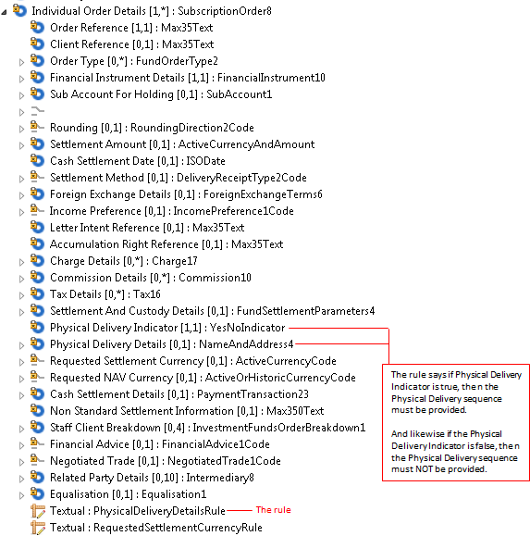
If the change request for the deletion of ‘cancel by details’ is agreed then this eliminates the need for changes to the cancellation messages (setr.002, setr.005, setr.008, setr.011, setr.047, setr.049, setr.051 and setr.053).

List of impacted message components
 | Setr.001 | Individual Order Details | Redemption Order 7
 | Setr.002 | Individual Order Details | Redemption Order 5
 | Setr.003 | Individual Execution Details | Redemption Execution 5
 | setr.004 | Multiple Order Details / Individual Order Details | Redemption Order 8
 | setr.005 | CancellationByOrderDetails \ Multiple Order Details \ Individual Order Derails | Redemption Order 6
 | Setr.006 | Individual Execution Details | Redemption Execution 6
 | Setr.007 | Individual Order Details | Subscription Order 7
 | Setr.008 | Individual Order Details | Subscription Order 5
 | Setr.009 | Individual Execution Details | Subscription Execution 5
 | setr.010 | Multiple Order Details \ Individual Order Details | Subscription Order 8
 | setr.011 | Cancellation By Order Details \ Multiple Order Details \ Individual Order Details | Subscription Order 6
 | setr.012 | Multiple Execution Details \ Individual Execution Details | Subscription Execution 6
 | Setr.047 | Individual Execution Details | Subscription Execution 6
 | Setr.048 | Individual Execution Details | Subscription Execution 6
 | Setr.049 | Individiual Execution Details | Subscription Execution 5
 | Setr.050 | Individual Execution Details | Subscription Execution 5
 | Setr.051 | Individual Execution Details | Redemption Execution 6
 | Setr.052 | Individual Execution Details | Redemption Execution 6
 | Setr.053 | Individual Execution Details | Redemption Execution 5
 | Setr.054 | Individual Execution Details | Redemption Execution 5
 | Setr.013 | Redemption Leg Details | Switch Redemption Leg Order 3
 | Setr.013 | Subscription Leg Details | Switch Subscription Leg Order 3
 | Setr.014 | Redemption Leg Details | Switch Redempition Leg Order 3
 | Setr.014 | Subscription Leg Details | Switch Suhbscription Leg Order 3
 | Setr.015 | Redemption Leg Details | Switch Redemption Leg Execution 3
 | Setr.015 | Subscription Leg Details | Switch Subscription Leg Execution 3
 | Setr.055 | Redemption Leg Details | Switch Redemption Executipon Leg 3
 | Setr.055 | Subscription Leg Details | Switch Subscription Executipon Leg 3
 | Setr.056 | Redemption Leg Details | Switch Redemption Executipon Leg 3
 | Setr.056 | Subscription Leg Details | Switch Subscription Executipon Leg 3
- Purpose of the change:
To make an existing cross-element rule ‘formal’ so that it can be validated automatically.
- Urgency of the request:
The next maintenance cycle in which the maintenance of orders is permitted.
- Business examples:
None.
- SEG recommendation:
Consider |  | X | Timing
 |  |  | - Next yearly cycle: 2016/2017  (the change will be considered for implementation in the yearly maintenance cycle which starts in 2016 and completes with the publication of new message versions in the spring of 2017) |  | X
- At the occasion of the next maintenance of the messages
(the change will be considered for implementation, but does not justify maintenance of the messages in its own right – will be pending until more critical change requests are received for the messages)
- Urgent unscheduled
(the change justifies an urgent implementation outside of the normal yearly cycle)
 |  |  | - Other timing:
Comments:

Reject
Reason for rejection:

