Change Request
for the update of ISO 20022 financial repository items
- Origin of the request:
A.1 Submitter: SWIFT sprl
A.2 Contact person: Karine Taquet, karine.taquet@swift.com, +32 2 655 3784
A.3 Sponsors: ECB
- Related messages:
semt.018.

- Description of the change request:
Realignment of transaction type SBRE (Borrowing Reallocation) and SLRE (Lending Reallocation) present in the MT 537 but missing in the semt.018.

- Purpose of the change:

Discrepancy between the MT 537 (Statement of Pending Transaction) and the semt.018 (Securities Transaction Pending Report) must be corrected.
In the MT 537 (Statement of Pending Transaction) the following Settlement Transaction Indicator SBRE (Borrowing Reallocation) and SLRE (Lending Reallocation) are present whereas in the equivalent ISO 20022 semt.018 message these codes are missing for the Securities Transaction Type. Moreover SBRE and SLRE are also present in the sese.024 therefore they should also be present in the pending report.
- Urgency of the request:
April/May 2016
By default, valid change requests introduced by June 1 and subsequently approved by the SEG will be included in the following yearly maintenance cycle which completes with the publication of new message versions in April/May of the following year, unless decided otherwise by the SEG.
If there is a need to have the new version of the related messages published earlier, the reason for the urgency of the maintenance and the expected consequences of a delay should be described here. Acceptance of such an unscheduled maintenance is subject to approval by the SEG and availability of a submitting organization to develop the new version of the messages.
Note: the ISO 20022 maintenance results in the publication of a new version of an ISO 20022 message. The actual implementation of such new version on networks and in user installations is not within the purview of ISO.

- Business examples:
semt.018 Securites Transaction Pending Report
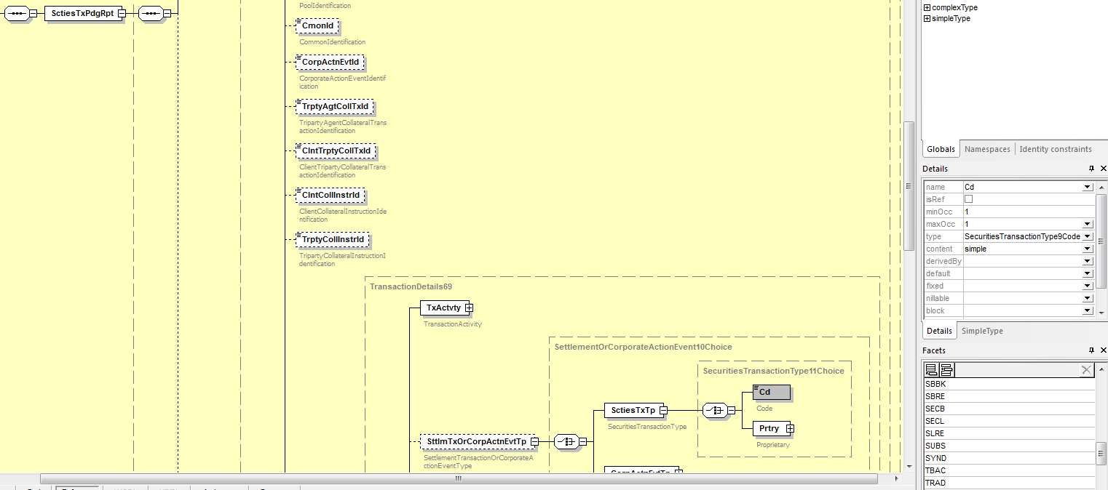

- SEG recommendation:

Consider |  | X | Timing
 |  |  | - Next yearly cycle: 2015/2016  (the change will be considered for implementation in the yearly maintenance cycle which starts in 2015 and completes with the publication of new message versions in the spring of 2016) |  | X
- At the occasion of the next maintenance of the messages
(the change will be considered for implementation, but does not justify maintenance of the messages in its own right – will be pending until more critical change requests are received for the messages)
- Urgent unscheduled
(the change justifies an urgent implementation outside of the normal yearly cycle)
 |  |  | - Other timing:
Comments:

Reject
Reason for rejection:

