Change Request
for the update of ISO 20022 financial repository items

- Origin of the request:
A.1 Submitter:
SWIFT
8 Marina View, Asia Square Tower 1, #28-04, Singapore 018960

A.2 Contact person:
Mr. David Dobbing SWIFT Standards Department
Tel: +65 8500 8056
Email: david.dobbing@swift.com

A.3 Sponsors:
Mr. Harri Rantanen
Global Formats and Standards Manager
SEB
Email: harri.rantanen@seb.fi

Ms. Selina Bolton
Global Transaction Banking
Deutsche Bank
Email: selina.bolton@db.com

CGI-MP Common Global Implementation – Market Practice
WG5 Working Group 5 (Bank Services Billing)

- Related messages:
BankService block in Service in BillingStatement

# | Message ID | Message Name
1 | camt.086.001.01 | BankServicesBillingStatementV01

- Description of the change request:
Request to add in the BankService <BkSvc> block, a new optional component to support the specification of the Bank Transaction Code (BTC), in alignment with the same component found in the account reporting messages (camt.052, camt.053, and camt.054).
Request that it be implemented along-side the Common Code <CmonCd> in the BankService <BkSvc> block, to support the use of either, or both, the BTC and/or Common Code.
A draft of the proposed structure is depicted for reference overleaf.

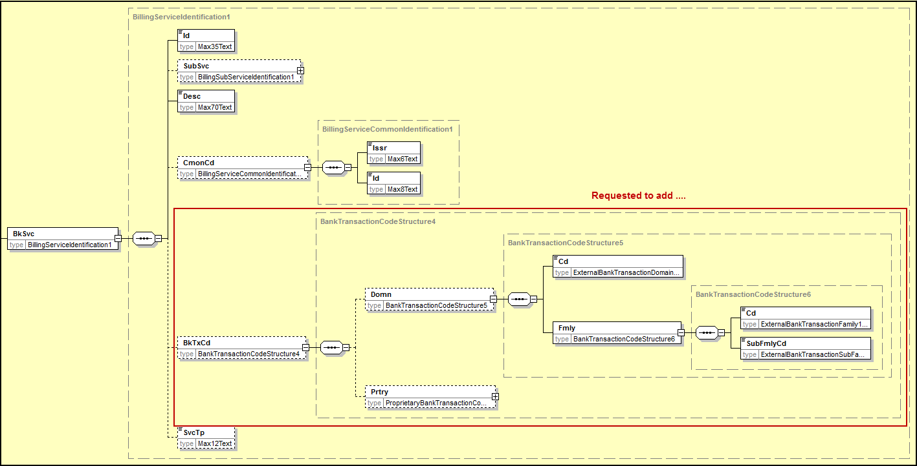

- Purpose of the change:
In terms of uniquely identifying bank services, the Bank Transaction Code (BTC) has featured in the set of existing Bank-to-Customer Cash Management ISO 20022 messages, notably the camt.052 (Bank To Customer Account Report), camt.053 (Bank To Customer Statement) and the camt.054 (Bank To Customer Debit Credit Notification). Support for the use of the same Bank Transaction Code in the camt.086 (Bank Services Billing) message is foreseen as important to ensure alignment across these message types and can be considered in addition to, or as an alternative to, the notion of the Common Code <CmonCd> found in the camt.086.

- Urgency of the request:
To be handled in accordance with the normal yearly maintenance cycle.

- Business examples:
Existing account reports have the Bank Transaction Code defined as a mandatory element and provide examples of its of usage.

- SEG recommendation:
Consider |  | X | Timing
 |  |  | - Next yearly cycle: 2015/2016  (the change will be considered for implementation in the yearly maintenance cycle which starts in 2015 and completes with the publication of new message versions in the spring of 2016) |  | X
- At the occasion of the next maintenance of the messages
(the change will be considered for implementation, but does not justify maintenance of the messages in its own right – will be pending until more critical change requests are received for the messages)
- Urgent unscheduled
(the change justifies an urgent implementation outside of the normal yearly cycle)
 |  |  | - Other timing:
Comments:

Reject
Reason for rejection:

