Change Request
for the update of ISO 20022 financial repository items

- Origin of the request:
A.1 Submitter:
- Deutsche Bundesbank, on behalf of the Eurosystem
- TARGET2-Securities Project

A.2 Contact person:
- Joachim Boening / Alexander Topel
- +49 69 – 9566 6839 / +49 69 – 9566 8184
- T2S-FAM@bundesbank.de

A.3 Sponsors:
- Clearstream Banking Frankfurt; Markus Glueck - markus.glueck@deutsche-boerse.com
- European Central Bank; Karen Birkel - karen.birkel@ecb.int
- TARGET2-Securities Community

- Related messages:
- semt.002.001.08 - SecuritiesBalanceCustodyReportV08

- Description of the change request:
Business context:
T2S allows defining in T2S Static data securities accounts that may hold negative positions (authorised to be negative) in addition to positive positions. Securities accounts which are allowed to hold negative positions are typically used for specific purpose, e.g.
- issuance accounts,
- mirror accounts or inter-CSD accounts,
- technical accounts for CSD internal processing or for specific customers such as central banks.
If accounts are allowed to have negative positions, then they might have a negative position in the Deliverable and/or in any Earmarked sub-position in a financial instrument.
In order to provide information of the different securities positions, even the negative Deliverable or Earmarked sub-positions, the SecuritiesBalanceCustodyReport (semt.002) offers only a Short/Long Indicator for the “Aggregated Balance” (see screenshot below).
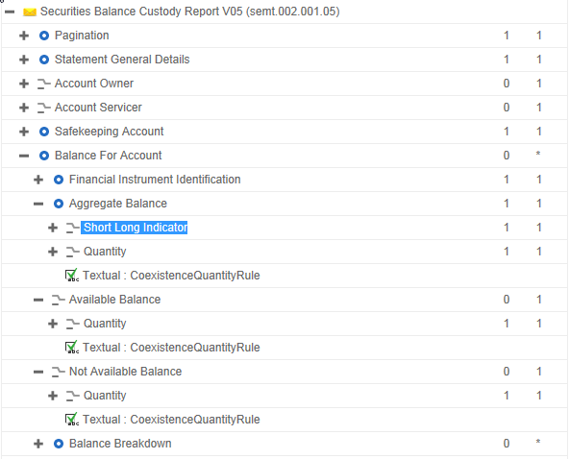

For Available Balance, Not Available Balance or any further breakdown details, the semt.002 does not offer the Short/Long Indicator field.
- The “Not Available” positions in T2S (i.e. Collateralized, blocked, reserved and CoSD blocked positions) cannot be negative in T2S, hence not having the Short/Long Indicator field in the Not Available Balance and in all subsequent balance breakdowns does not have any impact on the T2S community.
- However, the “Available” positions can be negative in T2S, and so can any more detailed balance in subsequent balance breakdowns, e.g. Deliverable or the different earmarking position types. Moreover, negative positions in the Deliverable can coexist with positive or negative positions in earmarked position types. Similarly, negative positions in one earmarked position type can coexist with other positive or negative positions in other earmarked position types, and with positive or negative Deliverable. For the time being, it is not possible to report such positions with the correct Short/Long Indicator

As a result, the current ISO standard for the semt.002 message supports only the reporting of the absolute value of any available sub-position, but not the reporting of the actual sign of the position.
This can lead to situations where the receiver of a semt.002 message cannot decide out of the message content whether a given sub-position has actually positive or negative sign, in particular in situations where Deliverable position and various Earmarked positions with different sign coexist on a given account.
This is considered a gap, in particular as many CSDs will base the reconciliation of their internal positions versus T2S positions on the semt.002 message. This implies that T2S must properly report any detailed position on any account, including accounts which can have negative position such as issuance or mirror accounts, so that there is no ambiguity about the sign of the positions being reported.
One could consider the actual behavior also a gap versus the current ISO 15022 message MT535 where each position on any breakdown level can be reported with a negative sign.
Nature of the change:
To provide a Short/Long Indicator in the semt.002 message at least prior to the following attributes:
<BalForAcct><AggtBal><Qty> (<ShrtLngInd>existing)
<BalForAcct><AvlblBal><Qty> (<ShrtLngInd> to be added prior to this tag)
<BalForAcct><BalBrkdwn><Qty> (<ShrtLngInd> to be added prior to this tag)
<BalForAcct><BalBrkdwn><AddtlBalBrkdwnDtls><Qty> (<ShrtLngInd> to be added prior to this tag)
These tags are the minimum required to update the semt.002 from a T2S perspective.
From an ISO perspective, it might also be beneficial to add the Short/Long Indicator to all quantities although they can only be positive in T2S and even to quantities not used in T2S. With such an approach, the behaviour would replicate what is possible in an MT535 where each position can have a sign.
- Purpose of the change:
Specific benefits of this change request:
The proposed change request will allow reporting a Short/Long indicator for all negative positions that might occur on T2S, on the aggregate balance as well as on the more detailed balance breakdowns.
With such a change, all positions on T2S can be reported with the proper sign which is a key requirement to support reconciliation processes of internal systems versus T2S at the level of the position detail that occurs on T2S.

- Urgency of the request:
We request the SEG to consider this change request for the next maintenance cycle, once we are planning to implement these changes as soon as possible in order to provide our participants more accurate information in the message.

- Business examples:
Report with multiple earmarked positions:
A participant has all its position available, some of them deliverable and some others earmarked but having multiple earmarked positions in a securities account for a certain ISIN.
The breakdown for the different available positions is the following:
A Deliverable AWAS securities position of -300
An Earmarked securities position of +600 in the Earmarking “EAR1”
An Earmarked securities position of -300 in the Earmarking “EAR2”
In this situation, the total available position is 0 (300-600+300). However, in this example it would be not possible to distinguish which of the sub-positions is the positive one and which is the negative one.
The relevant fields (BalanceForAccount message building block) of the semt.002 (prior to this Change Request) will be:
<BalForAcct>
<FinInstrmId>
<ISIN>ISIN01234567</ISIN>
</FinInstrmId>
<AggtBal>
<ShrtLngInd>LONG</ShrtLngInd>
<Qty>
<Qty>
<Qty>
<Unit>0</Unit>
</Qty>
</Qty>
</Qty>
</AggtBal>
<AvlblBal>
<Qty>
<Unit>0</Unit>
</Qty>
</AvlblBal>
<NotAvlblBal>
<Qty>
<Unit>0</Unit>
</Qty>
</NotAvlblBal>
<BalBrkdwn>
<SubBalTp>
<Cd>AWAS</Cd>
</SubBalTp>
<Qty>
<Qty>
<Unit>300</Unit>
</Qty>
</Qty>
</BalBrkdwn>
<BalBrkdwn>
<SubBalTp>
<Prtry>
<Id>EARM</Id>
<Issr>T2S</Issr>
<SchmeNm>RPT</SchmeNm>
</Prtry>
</SubBalTp>
<Qty>
<Qty>
<Unit>300</Unit>
</Qty>
</Qty>
<AddtlBalBrkdwnDtls>
<SubBalTp>
<Prtry>
<Id>EAR1</Id>
<Issr>T2S</Issr>
<SchmeNm>RT</SchmeNm>
</Prtry>
</SubBalTp>
<Qty>
<Qty>
<Unit>600</Unit>
</Qty>
</Qty>
<SubBalAddtlDtls>Earmarking on securities position</SubBalAddtlDtls>
</AddtlBalBrkdwnDtls>
<AddtlBalBrkdwnDtls>
<SubBalTp>
<Prtry>
<Id>EAR2</Id>
<Issr>T2S</Issr>
<SchmeNm>RT</SchmeNm>
</Prtry>
</SubBalTp>
<Qty>
<Qty>
<Unit>300</Unit>
</Qty>
</Qty>
<SubBalAddtlDtls>Earmarking on securities position 2</SubBalAddtlDtls>
</AddtlBalBrkdwnDtls>
</BalBrkdwn>
</BalForAcct>

- SEG recommendation:

Consider |  | X | Timing
 |  |  | - Next yearly cycle: 2015/2016  (the change will be considered for implementation in the yearly maintenance cycle which starts in 2015 and completes with the publication of new message versions in the spring of 2016) |  | X
- At the occasion of the next maintenance of the messages
(the change will be considered for implementation, but does not justify maintenance of the messages in its own right – will be pending until more critical change requests are received for the messages)
- Urgent unscheduled
(the change justifies an urgent implementation outside of the normal yearly cycle)
 |  |  | - Other timing:
Comments:

Reject
Reason for rejection:

It should be noted that it is not possible in T2S to configure accounts which hold only negative positions. It is only possible to configure accounts only for positive positions, or for positive and negative positions in parallel.

