Change Request
for the update of ISO 20022 financial repository items
- Origin of the request:
A.1 Submitter:
Swiss Commission for Financial Standardisation (SCFS).
A.2 Contact person:
Michael Rausch; michael.rausch@zkb.ch; +41 44 292 72 32
Rainer Vogelgesang, rainer.vogelgesang@six-group.com; +41 58 399 3808
A.3 Sponsors: /

- Related messages:
As the introduction of a new optional element for the description of financial instruments is a general change, all messages that have or can carry financial instrument information are related to that change request, especially the messages within the securities business domain:

TradeLegNotificationV03 secl.001.001.03
TradeLegNotificationCancellationV03 secl.002.001.03
TradeLegStatementV03 secl.003.001.03
NetPositionV03 secl.004.001.03
MarginReportV02 secl.005.001.02
DefaultFundContributionReportV02 secl.006.001.02
BuyInNotificationV03 secl.007.001.03
BuyInResponseV03 secl.008.001.03
BuyInConfirmationV03 secl.009.001.03
SettlementObligationReportV03 secl.010.001.03
CorporateActionNotificationV05 seev.031.001.05
CorporateActionEventProcessingStatusAdviceV04 seev.032.001.04
CorporateActionInstructionV05 seev.033.001.05
CorporateActionInstructionStatusAdviceV06 seev.034.001.06
CorporateActionMovementPreliminaryAdviceV06 seev.035.001.06
CorporateActionMovementConfirmationV06 seev.036.001.06
CorporateActionMovementReversalAdviceV06 seev.037.001.06
CorporateActionNarrativeV03 seev.038.001.03
CorporateActionCancellationAdviceV05 seev.039.001.05
CorporateActionInstructionCancellationRequestV05 seev.040.001.05
CorporateActionInstructionCancellationRequestStatusAdviceV05 seev.041.001.05
CorporateActionInstructionStatementReportV04 seev.042.001.04
CorporateActionMovementPreliminaryAdviceCancellationAdviceV05 seev.044.001.05
SecuritiesMessageRejectionV03 semt.001.001.03
CustodyStatementOfHoldingsV02 semt.002.001.02
AccountingStatementOfHoldingsV02 semt.003.001.02
CustodyStatementOfHoldingsCancellationV02 semt.004.001.02
AccountingStatementOfHoldingsCancellationV02 semt.005.001.02
StatementOfInvestmentFundTransactionsV03 semt.006.001.03
StatementOfInvestmentFundTransactionsCancellationV03 semt.007.001.03
PriceReportV04 reda.001.001.04
PriceReportCancellationV04 reda.002.001.04
FundProcessingPassportReportV02 reda.004.001.02
InvestmentFundReportRequestV02 reda.005.001.02
SecuritiesMessageRejectionV03 semt.001.001.03
CustodyStatementOfHoldingsV02 semt.002.001.02
AccountingStatementOfHoldingsV02 semt.003.001.02
CustodyStatementOfHoldingsCancellationV02 semt.004.001.02
PortfolioTransferInstructionV06 sese.012.001.06
AccountHoldingInformationV04 sese.018.001.04
AccountHoldingInformationRequestV03 sese.019.001.03
RedemptionBulkOrderV03 setr.001.001.03
RedemptionBulkOrderCancellationRequestV03 setr.002.001.03
RedemptionBulkOrderConfirmationV03 setr.003.001.03
RedemptionOrderV03 setr.004.001.03
RedemptionOrderCancellationRequestV03 setr.005.001.03
RedemptionOrderConfirmationV03 setr.006.001.03
SubscriptionBulkOrderV03 setr.007.001.03
SubscriptionBulkOrderCancellationRequestV03 setr.008.001.03
SubscriptionBulkOrderConfirmationV03 setr.009.001.03
SubscriptionOrderV03 setr.010.001.03
SubscriptionOrderCancellationRequestV03 setr.011.001.03
SubscriptionOrderConfirmationV03 setr.012.001.03
SwitchOrderV03 setr.013.001.03
SwitchOrderCancellationRequestV03 setr.014.001.03
SwitchOrderConfirmationV03 setr.015.001.03
OrderInstructionStatusReportV03 setr.016.001.03
OrderCancellationStatusReportV03 setr.017.001.03
RequestForOrderStatusReportV03 setr.018.001.03
SubscriptionOrderConfirmationCancellationInstructionV01 setr.047.001.01
SubscriptionOrderConfirmationAmendmentV01 setr.048.001.01
SubscriptionBulkOrderConfirmationCancellationInstructionV01 setr.049.001.01
SubscriptionBulkOrderConfirmationAmendmentV01 setr.050.001.01
RedemptionOrderConfirmationCancellationInstructionV01 setr.051.001.01
RedemptionOrderConfirmationAmendmentV01 setr.052.001.01
RedemptionBulkOrderConfirmationCancellationInstructionV01 setr.053.001.01
RedemptionBulkOrderConfirmationAmendmentV01 setr.054.001.01
SwitchOrderConfirmationCancellationInstructionV01 setr.055.001.01
SwitchOrderConfirmationAmendmentV01 setr.056.001.01
OrderConfirmationStatusReportV01 setr.057.001.01
RequestForOrderConfirmationStatusReportV01 setr.058.001.01
AgentCANotificationAdviceV01 seev.009.001.01
AgentCANotificationCancellationRequestV01 seev.010.001.01
AgentCANotificationStatusAdviceV01 seev.011.001.01
AgentCAElectionAdviceV01 seev.012.001.01
AgentCAElectionAmendmentRequestV01 seev.013.001.01
AgentCAElectionCancellationRequestV01 seev.014.001.01
AgentCAElectionStatusAdviceV01 seev.015.001.01
AgentCADistributionBreakdownAdviceV01 seev.016.001.01
AgentCAGlobalDistributionAuthorisationRequestV01 seev.017.001.01
AgentCAGlobalDistributionStatusAdviceV01 seev.018.001.01
AgentCAMovementInstructionV01 seev.019.001.01
AgentCAMovementCancellationRequestV01 seev.020.001.01
AgentCAMovementConfirmationV01 seev.021.001.01
AgentCAMovementStatusAdviceV01 seev.022.001.01
AgentCAInformationAdviceV01 seev.023.001.01
AgentCAInformationStatusAdviceV01 seev.024.001.01
AgentCAStandingInstructionRequestV01 seev.025.001.01
AgentCAStandingInstructionCancellationRequestV01 seev.026.001.01
AgentCAStandingInstructionStatusAdviceV01 seev.027.001.01
AgentCADeactivationInstructionV01 seev.028.001.01
AgentCADeactivationCancellationRequestV01 seev.029.001.01
AgentCADeactivationStatusAdviceV01 seev.030.001.01
SecuritiesEndOfProcessReportV01 semt.023.001.01
SecuritiesTradeConfirmationV03 setr.027.001.03
SecuritiesTradeConfirmationCancellationV01 setr.029.001.01
SecuritiesTradeConfirmationResponseV01 setr.030.001.01
SecuritiesTradeConfirmationStatusAdviceV02 setr.044.001.02
MeetingNotificationV05 seev.001.001.05
MeetingCancellationV05 seev.002.001.05
MeetingEntitlementNotificationV05 seev.003.001.05
MeetingInstructionV05 seev.004.001.05
MeetingInstructionCancellationRequestV05 seev.005.001.05
MeetingInstructionStatusV05 seev.006.001.05
MeetingVoteExecutionConfirmationV05 seev.007.001.05
MeetingResultDisseminationV05 seev.008.001.05
SecuritiesBalanceCustodyReportV08 semt.002.001.08
SecuritiesBalanceAccountingReportV08 semt.003.001.08
IntraPositionMovementInstructionV03 semt.013.001.03
IntraPositionMovementStatusAdviceV03 semt.014.001.03
IntraPositionMovementConfirmationV04 semt.015.001.04
IntraPositionMovementPostingReportV04 semt.016.001.04
SecuritiesTransactionPostingReportV05 semt.017.001.05
SecuritiesTransactionPendingReportV06 semt.018.001.06
SecuritiesSettlementTransactionAllegementReportV04 semt.019.001.04
SecuritiesMessageCancellationAdviceV04 semt.020.001.04
SecuritiesStatementQueryV05 semt.021.001.05
SecuritiesSettlementTransactionAuditTrailReportV02 semt.022.001.02
TotalPortfolioValuationReportV01 semt.024.001.01
RegulatoryTransactionReportV02 auth.008.001.02
RegulatoryTransactionReportCancellationRequestV02 auth.009.001.02
RegulatoryTransactionReportStatusV01 auth.010.001.01
RegulatoryTransactionReportCancellationStatusV01 auth.011.001.01

- Description of the change request:
In 2015 the ISO 18774 Standard “Financial Instruments Short Name” was released. Every participant using that standard in its applications to identify and describe financial instruments will be able to use the same terms in financial messaging (in- and outgoing) as well. By giving the possibility to carry FISN within financial messages, identifying of financial instruments within financial messages will be unified and so can reduce misunderstandings, processing errors and therefore costs.
It is supposed to extend the structure for the description and identification of a Financial Instrument, for example “Financial Instrument 10” within setr.010.001.03 [SubscriptionOrderV03] by an additional, optional element “FISN” [type: xs:string; length: max35].
The change is to be implemented in all the related messages mentioned above.
It is supposed to extend the same or similar structure occurring in other messages of other business domains as well.
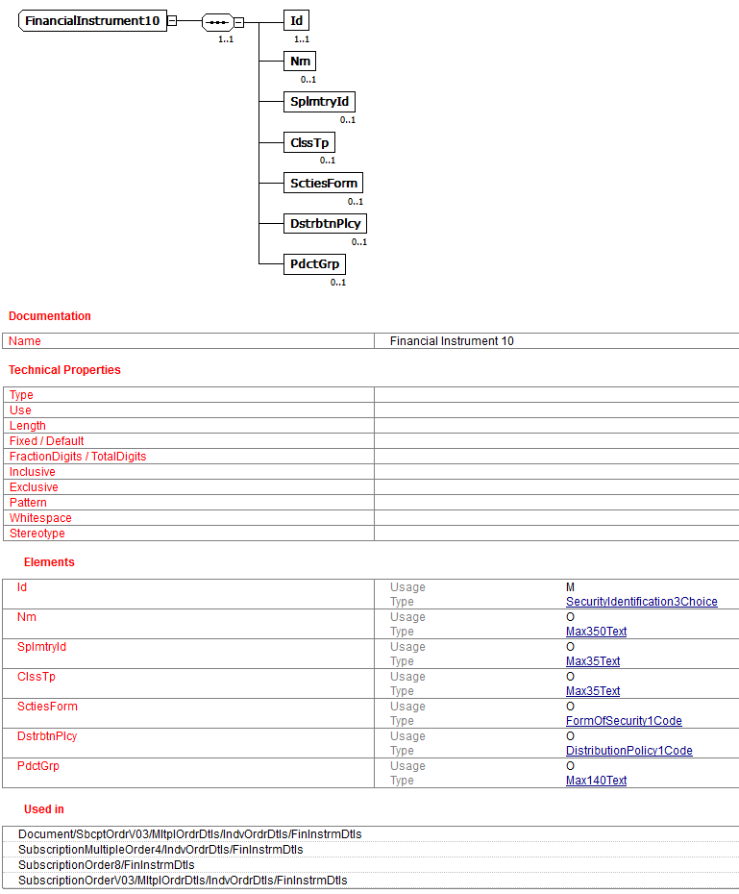
figure 1: FinancialInstrument10-structure within setr.010.001.03 [source: SCFS validation portal for the SCFS Investment Funds Market Practice]

- Purpose of the change:
As FISN has become an official ISO Standard there should be the possibility to use that standard in order to enhance the quality of financial messaging.

- Urgency of the request:
No special requirements.

- Business examples:
--
- SEG recommendation:

Consider |  | X | Timing
 |  |  | - Next yearly cycle: 2015/2016  (the change will be considered for implementation in the yearly maintenance cycle which starts in 2015 and completes with the publication of new message versions in the spring of 2016) |  | X
 |  |  | - At the occasion of the next maintenance of the messages  (the change will be considered for implementation, but does not justify maintenance of the messages in its own right – will be pending until more critical change requests are received for the messages) |  | X
- Urgent unscheduled
(the change justifies an urgent implementation outside of the normal yearly cycle)
 |  |  | - Other timing:
Comments:
For Investment Funds messages: It should be added to all the messages that have a Financial Instrument component. The implementation should take place when there is another business change accepted that impacts the messages: ‘acmt’ and ‘sese’ messages in 2015/2016, ‘setr’ messages in 2016/2017 (see appendix), later for the other messages.
For the other securities message sets: the proposed implementation is rejected. To avoid having to change the messages, the Securities SEG proposes to the SCFS to introduce a change request to add the FISN in the External Code Set “Financial Instrument ID Type” which is used in these securities messages.

Reject
Reason for rejection:

APPENDIX MARCH 2016
For the 2016-2017 maintenance cycle, it has been agreed by funds industry (Funds IF SMPG and Funds Migration Advisory Group) that the investment fund order (setr) messages are to be maintained.
It is proposed that this change request is applied as part of the 2016-2017 maintenance cycle. The list of investment fund order (setr) messages impacted:
 | Message | Identifier |  |  | Message | Identifier
 | Redemption Bulk Order | setr.001.001.03 |  |  | Switch Order Confirmation | setr.015.001.03
 | Redemption Bulk Order Cancellation Request | setr.002.001.03 |  |  | Order Instruction Status Report | setr.016.001.03
 | Redemption Bulk Order Confirmation | setr.003.001.03 |  |  | Order Cancellation Status Report | setr.017.001.03
 | Redemption Order | setr.004.001.03 |  |  | Subscription Order Confirmation Cancellation Instruction | setr.047.001.01
 | Redemption Order Cancellation Request | setr.005.001.03 |  |  | Subscription Order Confirmation Amendment | setr.048.001.01
 | Redemption Order Confirmation | setr.006.001.03 |  |  | Subscription Bulk Order Confirmation Cancellation Instruction | setr.049.001.01
 | Subscription Bulk Order | setr.007.001.03 |  |  | Subscription Bulk Order Confirmation Amendment | setr.050.001.01
 | Subscription Bulk Order Cancellation Request | setr.008.001.03 |  |  | Redemption Order Confirmation Cancellation Instruction | setr.051.001.01
 | Subscription Bulk Order Confirmation | setr.009.001.03 |  |  | Redemption Order Confirmation Amendment | setr.052.001.01
 | Subscription Order | setr.010.001.03 |  |  | Redemption Bulk Order Confirmation Cancellation Instruction | setr.053.001.01
 | Subscription Order Cancellation Request | setr.011.001.03 |  |  | Redemption Bulk Order Confirmation Amendment | setr.054.001.01
 | Subscription Order Confirmation | setr.012.001.03 |  |  | Switch Order Confirmation Cancellation Instruction | setr.055.001.01
 | Switch Order | setr.013.001.03 |  |  | Switch Order Confirmation Amendment | setr.056.001.01
 | Switch Order Cancellation | setr.014.001.03 |  |  | Order Confirmation Status Report | setr.057.001.01
The list of messages in section B, for funds setr messages has too many messages. This change does not need to be applied to the request report messages (setr.018 and 058).
This change has already been carried out to the investment funds account management (acmt) messages and the investment funds transfer (sese) messages as a result of CR 509, submitted by SCFS in 2015. The CR was rejected for the other securities messages
In Financial Instrument Details, add element Short Name [0.1], definition (“Financial Instrument Short Name (FISN) expressed in conformance with the ISO 18774 standard.”). This element can be copied from acmt.001.001.06.

