Change Request
for the update of ISO 20022 financial repository items

- Origin of the request:
A.1 Submitter: Tieto on behalf of Swedish Banker’s Association
A.2 Contact person:
Ulrika Sjödahl, ulrika.sjodahl@tieto.com, +46104818037
Pirkko Vedenpää, pirkko.vedenpaa@tieto.com, +358207257525
A.1 Sponsor: Tieto Corporation

- Related messages:
tsin.004.001.01 (FinancialInvoice)

- Description of the change request:
Add TAX information to all amounts to be able to indicate if TAX is included or not in the current amount. Add TxInd element to indicate if TAX is included or not. Also add TpCd -structure to show tax type.
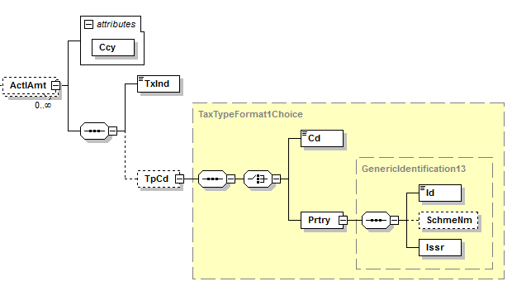

Impacted amount elements are:
- TradSttlm/DuePyblAmt
- TradSttlm/AllwncChrg/ActlAmt
- TradSttlm/LogstcsChrg/Amt
- TradSttlm/PmtTerms/DscntAmt
- TradSttlm/PmtTerms/DscntBsisAmt
- TradSttlm/PmtTerms/PnltyAmt
- TradSttlm/MntrySummtn/LineTtlAmt
- TradSttlm/MntrySummtn/TtlPrepdAmt
- TradSttlm/MntrySummtn/GrdTtlAmt
- TradSttlm/MntrySummtn/InfAmt

- LineItm/LogstcsChrg/Amt
- LineItm/AllwncChrg/ActlAmt
- LineItm/FinAdjstmnt/Amt
- LineItm/MntrySummtn/LineTtlAmt
- LineItm/MntrySummtn/InfAmt

- Purpose of the change:
The purpose of the change is to be able to tell if the amount is with or without TAX.
Description in the Message Definition Report does not tell if the amount described is with or without TAX.

- Urgency of the request:
Normal.
- Business examples:
In Sweden and Finland it is possible to invoice either with or without VAT included in the amounts. There can also be some amounts included VAT and other excluded VAT in the same invoice.

- SEG recommendation:

Consider |  | Y | Timing
- Next yearly cycle: 2012/2013
(the change will be considered for implementation in the yearly maintenance cycle which starts in 2012 and completes with the publication of new message versions in the spring of 2013)
 |  |  | - At the occasion of the next maintenance of the messages  (the change will be considered for implementation, but does not justify maintenance of the messages in its own right – will be pending until more critical change requests are received for the messages) |  | X
- Urgent unscheduled
(the change justifies an urgent implementation outside of the normal yearly cycle)
 |  |  | - Other timing:
Comments:

Reject
Reason for rejection:

